


S-123
Published by the
International Hydrographic Organization
4b quai Antoine 1er
Principauté de Monaco
Tel: (377) 93.10.81.00
Fax: (377) 93.10.81.40
info@iho.int
www.iho.int
Marine Radio Services Product Specification

Edition 2.0.0 – March 2026

© Copyright International Hydrographic Organization September 26
This work is copyright. Apart from any use permitted in accordance with the Berne Convention for the Protection of Literary and Artistic Works (1886), and except in the circumstances described below, no part may be translated, reproduced by any process, adapted, communicated or commercially exploited without prior written permission from the International Hydrographic Organization Secretariat (IHO Secretariat). Copyright in some of the material in this publication may be owned by another party and permission for the translation and/or reproduction of that material must be obtained from the owner.
This document or partial material from this document may be translated, reproduced or distributed for general information, on no more than a cost recovery basis. Copies may not be sold or distributed for profit or gain without prior written agreement of the IHO Secretariat acting for the IHO and any other copyright holders.
In the event that this document or partial material from this document is reproduced, translated or distributed under the terms described above, the following statements are to be included:
“Material from IHO publication [reference to extract: Title, Edition] is reproduced with the permission of the International Hydrographic Organization Secretariat (IHO Secretariat) (Permission No ……./…) acting for the International Hydrographic Organization (IHO), which does not accept responsibility for the correctness of the material as reproduced: in case of doubt, the IHO’s authentic text shall prevail. The incorporation of material sourced from IHO shall not be construed as constituting an endorsement by IHO of this product.”
“This [document/publication] is a translation of IHO [document/publication] [name]. The IHO has not checked this translation and therefore takes no responsibility for its accuracy. In case of doubt the source version of [name] in [language] should be consulted.”
The IHO Logo or other identifiers shall not be used in any derived product without prior written permission from the IHO Secretariat.

Revision History
Changes to this Product Specification are coordinated by the IHO Nautical Information Provision Working Group (NIPWG). New editions will be made available via the IHO web site. Maintenance of the Product Specification shall conform to IHO Technical Resolution 2/2007 (revised 2010).

Version Number | Date | Author | Purpose
1.0.0 draft 2 | 2017/07/14 | EM | Apply revisions from NIPWG review
1.0.0 Release Candidate 1 | 2017-08-20 | RM | Update datasets, updated application schema according to NIPWG review
1.1.0 draft 1 | 2025-05-31 | Shwu-Jing Chang | Apply NIPWG approved change package of data model revision, and align with S-100 Edition 5.2.0.
1.2.0 draft 1 | 2025-07-05 | Shwu-Jing Chang | Include SAR region, TMAS, Ice Report, NAVDAT to data model. Revise or add generic attributes for encoding radionavigation services.
2.0.0 draft 1 | 2025-12-10 | Shwu-Jing Chang | Update figures and contents to align with renamed items accepted in GI Registry; Correct typo in 10.2.6.3 PT_Locale.
2.0.0 draft 2 | 2025-12-11 | Shwu-Jing Chang | Change one of the theComponent roles to theFuzzyComponent
2.0.0 draft 3 | 2026-01-19 | Shwu-Jing Chang | Refine the document and relax some multiplicity restrictions on discovery metadata.
2.0.0 draft 4 | 2026-03-23 | Shwu-Jing Chang | Apply revisions from NIPWG review

Page intentionally left blank

TABLE OF CONTENTS
1 Overview 8
1.1 Introduction 8
1.2 Scope 8
1.3 References 8
1.4 Terms, definitions and abbreviations 9
1.4.1 Use of language 9
1.4.2 Terms and definitions 9
1.4.3 Abbreviations 10
1.5 General data product description 11
1.6 Data product specification metadata 11
1.7 IHO product specification maintenance 12
1.7.1 Introduction 12
1.7.2 New Edition 12
1.7.3 Revisions 12
1.7.4 Clarification 12
1.7.5 Version Numbers 13
2 Specification Scope 13
3 Data Product Identification 13
4 Data Content and Structure 14
4.1 Introduction 14
4.2 Application Schema 14
4.2.1 Domain model 14
4.2.1.1 Overview of domain features and information types 15
4.2.1.2 Radio stations and services 17
4.2.1.3 Daily schedules and business hours 20
4.2.1.4 Specific service area types 20
4.2.1.5 SAR and Telemedical Assistance Service 26
4.2.1.6 Radionavigation Service such as DGNSS 26
4.2.1.7 Regulations, information notes, etc. 27
4.2.1.8 Regulations applying in specific geographic features 28
4.2.1.9 Regulations applying only to vessels with specific characteristics or cargoes 29
4.2.1.10 Fuzzy areas in the S-123 application schema 31
4.2.1.11 Uncategorized additional information 32
4.2.2 Meta features 33
4.2.3 Spatial quality information type 33
4.3 Feature catalogue 34
4.3.1 Introduction 34
4.3.2 Feature types 34
4.3.2.1 Geographic 34
4.3.2.2 Meta 34
4.3.2.3 Cartographic 34
4.3.3 Information Types 35
4.3.4 Feature and information relationships 35
4.3.5 Attributes 35
4.3.5.1 Simple Attributes 35
4.3.5.2 Complex Attributes 35
4.4 Geometric Representation 35
4.5 Coordinate Reference System (CRS) 35
4.5.1 Horizontal Coordinate Reference System 35
4.5.2 Projection 35
4.5.3 Temporal reference system 35
4.6 Geometry 35
4.6.1 S-123 geometry 35
4.6.2 MRS data and scale 36
4.6.3 Coordinate encoding in spatial primitives 36
5 Data Quality 36
5.1 Introduction 36
5.2 Quality measure elements 37
5.2.1 Completeness 39
5.2.1.1 Commission 39
5.2.1.2 Omission 40
5.2.2 Logical consistency 40
5.2.2.1 Conceptual consistency 40
5.2.2.2 Domain consistency 40
5.2.2.3 Format consistency 40
5.2.2.4 Topological consistency 40
5.2.3 Positional accuracy 41
5.2.3.1 Absolute or external accuracy 41
5.2.3.2 Horizontal position accuracy 41
5.2.4 Thematic accuracy 41
5.2.4.1 Thematic classification correctness 41
5.2.4.2 Non-quantitative attribute accuracy 41
5.2.4.3 Quantitative attribute accuracy 41
5.2.5 Temporal quality 42
5.2.5.1 Temporal consistency 42
5.2.5.2 Temporal validity 42
5.2.5.3 Temporal accuracy 42
5.2.6 Aggregation 42
5.3 Data compliance and usability 42
6 Data capture and classification 43
7 Data Product Format (Encoding) 43
7.1 Introduction 43
7.2 Encoding of latitude and longitude 43
7.3 Numeric Attribute Encoding 43
7.4 Text Attribute Values 44
7.5 Mandatory Attribute Values 44
7.6 Unknown Attribute Values 44
7.7 Object identifiers 44
7.8 Data coverage 44
7.9 Data overlap 44
7.10 Data quality meta-features 44
7.11 Data extent 44
7.12 Content of update datasets 44
7.13 Attribute multiplicity 45
8 Data Product Delivery 45
8.1 Exchange set 45
8.2 Dataset 46
8.2.1 Types of Datasets 46
8.2.2 Dataset naming convention 46
8.2.3 Update dataset naming convention 47
8.2.4 Dataset size 47
8.2.5 New Editions, re-issues, updates and cancellations 47
8.2.6 Dataset loading 48
8.3 Support Files 48
8.3.1 Support File Naming Convention 49
8.3.2 Support file management 49
8.4 Exchange catalogue 50
9 Portrayal 51
9.1 Introduction 51
9.2 Portrayal catalogue 51
10 Metadata 51
10.1 Introduction 51
10.2 Discovery metadata 51
10.2.1 S100_ExchangeCatalogue 52
10.2.1.1 S100_ExchangeCatalogueIdentifier 53
10.2.1.2 S100_CataloguePointOfContact 53
10.2.2 S100_DatasetDiscoveryMetadata 54
10.2.3 S100_NavigationPurpose 57
10.2.4 S100_DataCoverage 57
10.2.4.1 S100_Purpose 58
10.2.4.2 S100_EncodingFormat 58
10.2.4.3 S100_ProductSpecification 59
10.2.4.4 S100_CompiancyCategory 59
10.2.4.5 S100_ProtectionScheme 60
10.2.4.6 S100_SupportFileDiscoveryMetadata 60
10.2.4.7 S100_SupportFileFormat 61
10.2.4.8 S100_SupportFileRevisionStatus 62
10.2.4.9 S100_SupportFileSpecification 62
10.2.4.10 S100_ResourcePurpose 62
10.2.5 S100_CatalogueDiscoveryMetadata 63
10.2.5.1 S100_CatalogueScope 64
10.2.6 Miscellaneous metadata types 64
10.2.6.1 MD_MaintenanceInformation 64
10.2.6.2 MD_MaintenanceFrequencyCode 65
10.2.6.3 PT_Locale 65
10.2.6.4 EX_GeographicBoundingBox 66
10.3 Language 67

Overview

Introduction
This document has been produced by the IHO Nautical Information Provision Working Group (NIPWG) in response to a requirement to produce a data product that can be used within an Electronic Chart Display and Information Systems (ECDIS). It is based on the IHO S-100 framework specification and the ISO 19100 series of standards. It is a vector product specification primarily intended for encoding the extent and nature of Radio Services, for navigational purposes.

Radio services describe the availability and reliability of radio stations and services offering navigational warnings and weather forecasts. This includes their service areas, services offered and instructions for contacting or utilizing these services.

Scope
This document describes an S-100 compliant Product Specification for Marine Radio Services, which will form an overlay layer for an S-100 based marine navigation system. It specifies the content, structure, and metadata needed for creating a fully compliant S-123 product and for its portrayal within an S-100 system. This Product Specification includes the content model, the encoding, the Feature Catalogue, Portrayal Catalogue, and metadata.

References
IHO S-100 IHO Universal Hydrographic Data Model, Edition 5.2.0
ISO 639-2/T Codes for the representation of names of languages – Part 2: Alpha-3 code
ISO 3166-1 Codes for the representation of names of countries and their subdivisions – Part 1: Country code
ISO 8601:2004 Data elements and interchange formats – Information interchange – Representation of dates and times
ISO 19101-1:2014 Geographic information – Reference Model –Part 1: Fundamentals
ISO 19107:2019 Geographic information – Spatial schema
ISO 19109:2015 Geographic information – Rules for application schema
ISO 19115-1:2014 Geographic information – Metadata – Part 1 - Fundamentals
ISO 19115-3:2023 Geographic information - Metadata - XML schema implementation for fundamental concepts
ISO 19117:2012 Geographic information – Portrayal
ISO 19123:2005 Geographic information - Schema for coverage geometry and functions
ISO 19136-1:2020 Geographic information – Geography Markup Language (GML) – Part 1 - Fundamentals
ISO 19136-2:2015 Geographic information – Geography Markup Language (GML) – Part 2 – Extended schemas and encoding rules
ISO/TS 19139-1:2019 Geographic information – XML schema implementation – Part 1 – Encoding rules
ISO 19157:2013 Geographic Information – Data Quality
ISO/IEC 19501:2005 Information technology – Unified Modelling Language (UML), Version 1.4.2

Terms, definitions and abbreviations

Use of language
Within this document:
- “Must” indicates a mandatory requirement.
- “Should” indicates an optional requirement, that is the recommended process to be followed, but is not mandatory.
- “May” means “allowed to” or “could possibly”, and is not mandatory.

Terms and definitions
The S-100 framework is based on the ISO 19100 series of geographic standards. The terms and definitions provided here are used to standardize the nomenclature found within that framework, whenever possible. They are taken from the references cited in clause 1.3. Modifications have been made when necessary.

application
manipulation and processing of data in support of user requirements (ISO 19101)

application schema
conceptual schema for data required by one or more applications (ISO 19101)

conceptual model
model that defines concepts of a universe of discourse (ISO 19101)

conceptual schema
formal description of a conceptual model (ISO 19101)

coverage
feature that acts as a function to return values from its range for any direct position within its spatial, temporal or spatiotemporal domain (ISO 19123)
EXAMPLE Raster image, polygon overlay, digital elevation matrix.

data product
dataset or dataset series that conforms to a data product specification

data product specification
detailed description of a dataset or dataset series together with additional information that will enable it to be created, supplied to and used by another party
NOTE: A data product specification provides a description of the universe of discourse and a specification for mapping the universe of discourse to a dataset. It may be used for production, sales, end-use or other purpose.

dataset
identifiable collection of data (ISO 19115)
NOTE: A dataset may be a smaller grouping of data which, though limited by some constraint such as spatial extent or feature type, is located physically within a larger dataset. Theoretically, a dataset may be as small as a single feature or feature attribute contained within a larger dataset. A hardcopy map or chart may be considered a dataset.

dataset series
collection of datasets sharing the same product specification (ISO 19115)

domain
well-defined set (ISO/TS 19103)
NOTE: Well-defined means that the definition is both necessary and sufficient, as everything that satisfies the definition is in the set and everything that does not satisfy the definition is necessarily outside the set.

feature
abstraction of real world phenomena (ISO 19101)
NOTE: A feature may occur as a type or an instance. Feature type or feature instance shall be used when only one is meant.

feature association
relationship that links instances of one feature type with instances of the same or a different feature type (ISO19110)
NOTE 1; A feature association may occur as a type or an instance. Feature association type or feature association instance is used when only one is meant.
NOTE 2: Feature associations include aggregation of features.

feature attribute
characteristic of a feature (ISO 19101)
NOTE 1: A feature attribute may occur as a type or an instance. Feature attribute type or feature attribute instance is used when only one is meant.
NOTE 2: A feature attribute type has a name, a data type and a domain associated to it. A feature attribute for a feature instance has an attribute value taken from the domain.

geographic data
data with implicit or explicit reference to a location relative to the Earth (ISO 19109)
NOTE: Geographic information is also used as a term for information concerning phenomena implicitly or explicitly associated with a location relative to the Earth.

metadata
data about data (ISO 19115)

model
abstraction of some aspects of reality (ISO 19109)

portrayal
presentation of information to humans (ISO 19117)

quality
totality of characteristics of a product that bear on its ability to satisfy stated and implied needs (ISO 19101)

universe of discourse
view of the real or hypothetical world that includes everything of interest (ISO 19101)

Abbreviations

This product specification adopts the following convention for symbols and abbreviated terms:
ASCII American Standard Code for Information Interchange
ECDIS Electronic Chart Display and Information Systems
ENC Electronic Navigational Chart
GML Geography Markup Language
IHO International Hydrographic Organization
IMO International Maritime Organization
ISO International Organization for Standardization
ITU International Telecommunication Union
MRCC Marine Rescue and Coordination Centre
MRSC Marine Rescue Sub-Centre
MSI Maritime Safety Information
NIPWG Nautical Information Provision Working Group
UML Unified Modelling Language
URI Uniformed Resource Identifier
URL Uniform Resource Locator
WWW World Wide Web
WGS World Geodetic System
WMO World Meteorological Organization
XML Extensible Markup Language

General data product description
This clause contains general information about the data product.

Title: Marine Radio Services

Abstract: Marine radio services product specification describe the means to capture availability and reliability of radio stations, radio position fixing systems, radio beacons, services offering navigational warnings and weather forecasts in the maritime domain. This may include details on the service areas, services offered and instructions for contacting or utilizing these services.

Content: Datasets conforming to this specification will contain all relevant maritime radio service information for the area of coverage. Additionally, there will be relevant metadata data quality, production authority, data sources and publication date.

Spatial Extent: Global coverage of maritime areas.

Purpose: Describing radio services in the maritime domain for utilization in ECDIS, and to allow the producer to exchange radio services information with interested stakeholders.

Data product specification metadata
This information uniquely identifies this Product Specification and provides information about its creation and maintenance. For further information on dataset metadata see the metadata clause.

Title: Marine Radio Services

S-100 Version: 5.2.0

S-123 Version: 2.0.0

Date: March 2026

Language: English

Classification: Unclassified

Contact: International Hydrographic Organization,
4 quai Antoine 1er,
B.P. 445
MC 98011 MONACO CEDEX
Telephone: +377 93 10 81 00
Fax: + 377 93 10 81 40

URL: http://www.iho.int

Identifier: S-123

Maintenance: Amendments to this specification will be produced on a needs basis. For reporting issues with this specification which need correction, use the contact information.

IHO product specification maintenance

Introduction
Changes to S-123 will be released by the IHO as a new edition, a revision, or as a document that includes clarification. These are described below.

New Edition
New Editions introduce significant changes. New Editions enable new concepts, such as the ability to support new functions or applications, or the introduction of new constructs or data types. New Editions are likely to have a significant impact on either existing users or future users of S-123.

Revisions
Revisions are defined as substantive semantic changes. Typically, revisions will introduce change to correct factual errors; introduce necessary changes that have become evident as a result of practical experience or changing circumstances. A revision must not be classified as a clarification. Revisions could have an impact on either existing users or future users of this specification. All cumulative clarifications will be included with the release of approved corrections revisions.

Changes in a revision are minor and ensure backward compatibility with the previous versions within the same Edition. Newer revisions, for example, introduce new features and attributes. Within the same Edition, a dataset of one version could always be processed with a later version of the feature and portrayal catalogues. In most cases a new feature or portrayal catalogue will result in a revision of this specification.

Clarification
Clarifications are non-substantive changes. Typically, clarifications: remove ambiguity; correct grammatical and spelling errors; amend or update cross references; insert improved graphics in spelling, punctuation and grammar. Clarification must not cause any substantive semantic changes.

Changes in a clarification are minor and ensure backward compatibility with the previous versions within the same Edition. Within the same Edition, a dataset of one clarification version could always be processed with a later version of the feature and portrayal catalogues, and a portrayal catalogue can always rely on earlier versions of the feature catalogues.

Changes in a clarification are minor and ensure backward compatibility with the previous versions.

Version Numbers
The associated version control numbering to identify changes (n) to this specification must be as follows:

New Editions denoted as n.0.0
Revisions denoted as n.n.0
Clarifications denoted as n.n.n

Specification Scope
This product specification describes one data product and therefore requires only one scope which is described below:

Scope ID: Global scope
Hierarchical level: MD_ScopeCode - 005
Hierarchical level name: Dataset
Extent: EX_Extent.description: Global coverage of maritime areas.

Data Product Identification
This section describes how to identify datasets that conform to the specification. A dataset that conforms to this Product Specification may be identified by its discovery metadata as defined in clause 10 of this specification. The information identifying the data product may include the following items from S-100 5.2.0 clause 11-6.

title | Marine Radio Services
abstract | Radio Services dataset is a vector dataset containing all maritime navigationally relevant information regarding the radio services within a defined geographical area.
acronym | MRS
topicCategory | utilitiesCommunication
geographicDescription | Areas specific to marine radio services
spatialResolution | All scales
purpose | Describing radio services in the maritime domain for utilization in ECDIS, and to allow the producer to exchange radio services information with interested stakeholders.
language | eng  Additional values if any. Use CharacterString values (alpha-3 code) from ISO 639-2.
spatialRepresentationType | Vector

Data Content and Structure

Introduction
The S-123 product is based on the S-100 General Feature Model (GFM), and is a feature-based vector product. All S-123 features and information classes are derived from one of the abstract classes FeatureType and InformationType defined in the S-123 application schema, which realize the GFM meta-classes S100_GF_FeatureType and S100_GF_InformationType respectively.

This section contains the Application Schema expressed in UML and an associated Feature Catalogue. The Feature Catalogue provides a full description of each feature type including its attributes, attribute values and relationships in the data product.

The classes comprising the S-123 application schema are divided into packages. The Domain model package contains the features and information types that model the MRS application domain specifically. Meta-features that provide quality and coverage information are contained within their own package. Features used for modeling approximate areas are contained within another package.

Geographic features in all packages use the spatial types from S-100 Part 7, which are imported as-is into the S-123 spatial types package and therefore can be used as types for S-123 spatial attributes. The spatial types package also contains definitions of ‘union types’ (combinations of the S-100 spatial types). S-100 allows features to have different kinds of geometry, however UML does not allow an attribute of a class to have multiple types. The S-123 application schema models spatial attributes as attributes of feature classes.

Application Schema
The UML models shown below are segments of the overall S-123 application schema, and include overviews of the feature classes, information classes, meta features, spatial types, and the relationships between them.

This section contains a general overview of the classes and relationships in the S-123 application schema. Detailed information about how to use the feature types and information types to encode Marine Radio Services information is provided in the S-123 Data Classification and Encoding Guide (DCEG).

The following conventions are used in the UML diagrams depicting the application schema:
- Standard UML conventions for classes, associations, inheritance, roles, and multiplicities apply. These conventions are described in Part 1 of S-100.
- Italic font for a class name indicates an abstract class.
- Feature classes are depicted with green background.
- Information type classes are depicted with blue background.
- Association classes are depicted with a white background.
- Complex attributes are depicted with a pink background.
- Enumeration lists and codelists are depicted with a tan background. The numeric code corresponding to each listed value is shown to its right following an ‘=’ sign.
- No significance attaches to the color of associations.

Domain model
The S-123 domain model has two base classes (‘root classes’) from which all the domain-specific geographic features and information type classes are derived. The base classes are shown in Figure 4-1 below. The base class for geographic features is FeatureType and the base class for information types is InformationType. Each of the two base classes has a set of attributes which are therefore inherited by all domain-specific features. Both base classes are abstract classes and do not have direct instances in S-123 data – instead, S-123 feature and information type data objects are instantiations of a non-abstract class derived from one of these base classes.

S-123 meta-features are not derived from these base classes – S-123 instead incorporates meta-feature definitions originally prepared for S-101 in the interests of harmonization and interoperability with other S-100-based data products, especially S-101 ENCs.

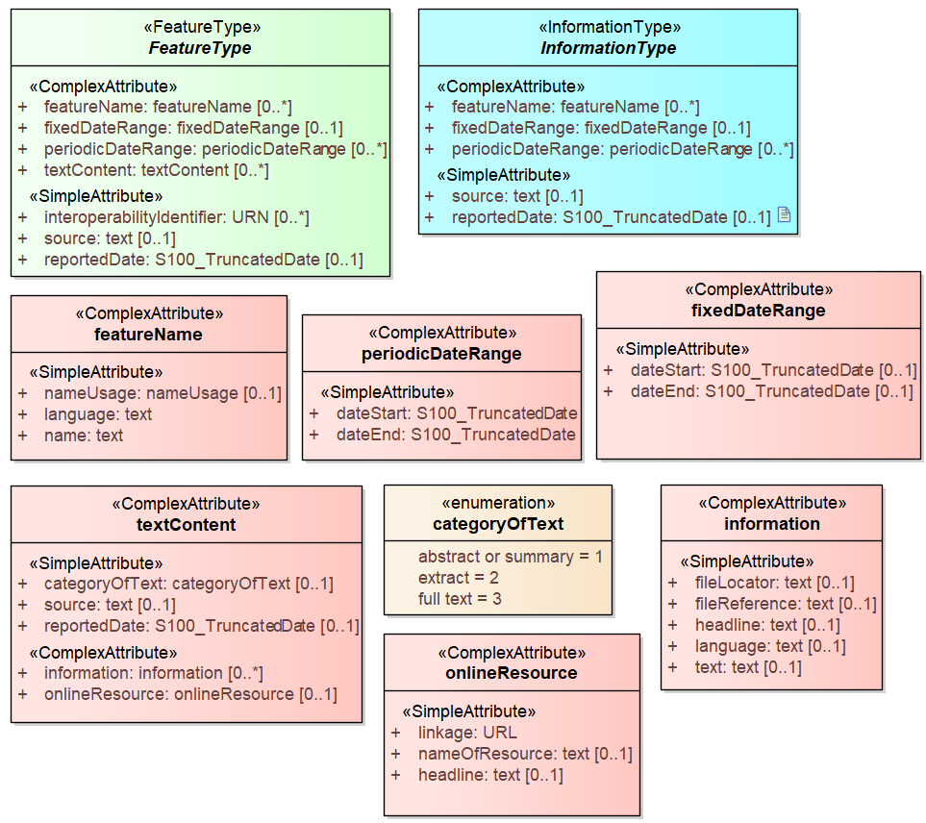
Figure 4-1. Base classes in S-123 and their attributes

Overview of domain features and information types
Marine Radio services data products include marine radio stations and services as well as safety and information broadcasts and radiocommunications. The scope of the S-123 domain model therefore includes NAVTEX, weather or ice forecasts and warnings, NAVAREAs and METAREAs defined by IMO and WMO, GMDSS sea areas declared by Coastal States. In addition, radio services providing IP-connectivity coverage are included in the domain model of S-123.
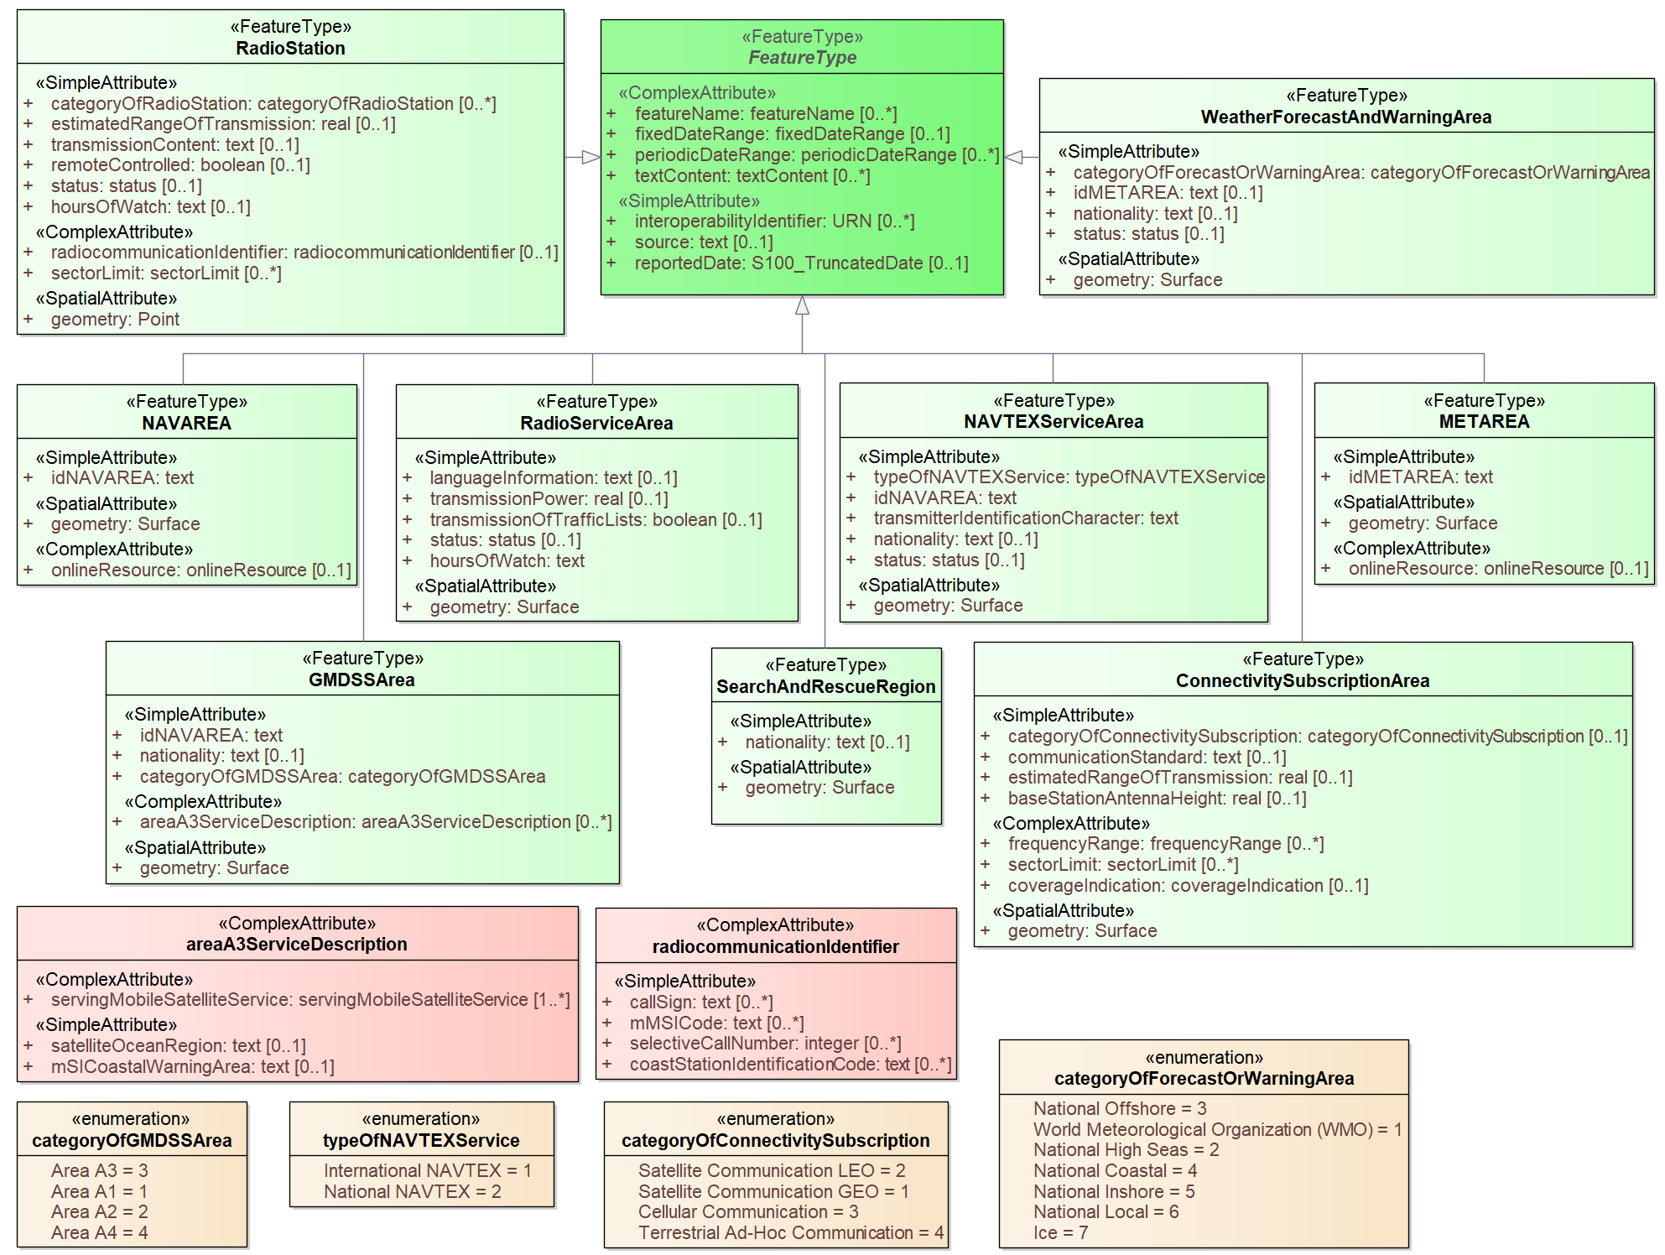
Figure 4-2. Overview of S-123 Feature Types
The abstract class FeatureType is an abstract class from which the geographic feature classes in the application schema are derived. FeatureType has attributes for fixed and periodic date ranges indicating the effective dates of the feature, name of the feature, source information, and a textContent attribute that allows text notes or references to be provided for individual feature instances where appropriate. The attributes defined in FeatureType are inherited by all S-123 geographic feature types. All the attributes in FeatureType are optional.

Geographic features use spatial types defined in the geometry package for spatial attributes. Datasets comprised of S-123 features are described by metadata as defined in the S-123 metadata package. Metadata uses selected spatial types (specifically, it uses the polygon type to describe the coverage of a dataset).

The S-123 application schema also includes modeling of locations where the availability of a service is intermittent or uncertain, usually dependent on atmospheric and weather conditions. This modeling is currently provided by aggregating areas of different reliabilities using a feature association to an aggregation feature.

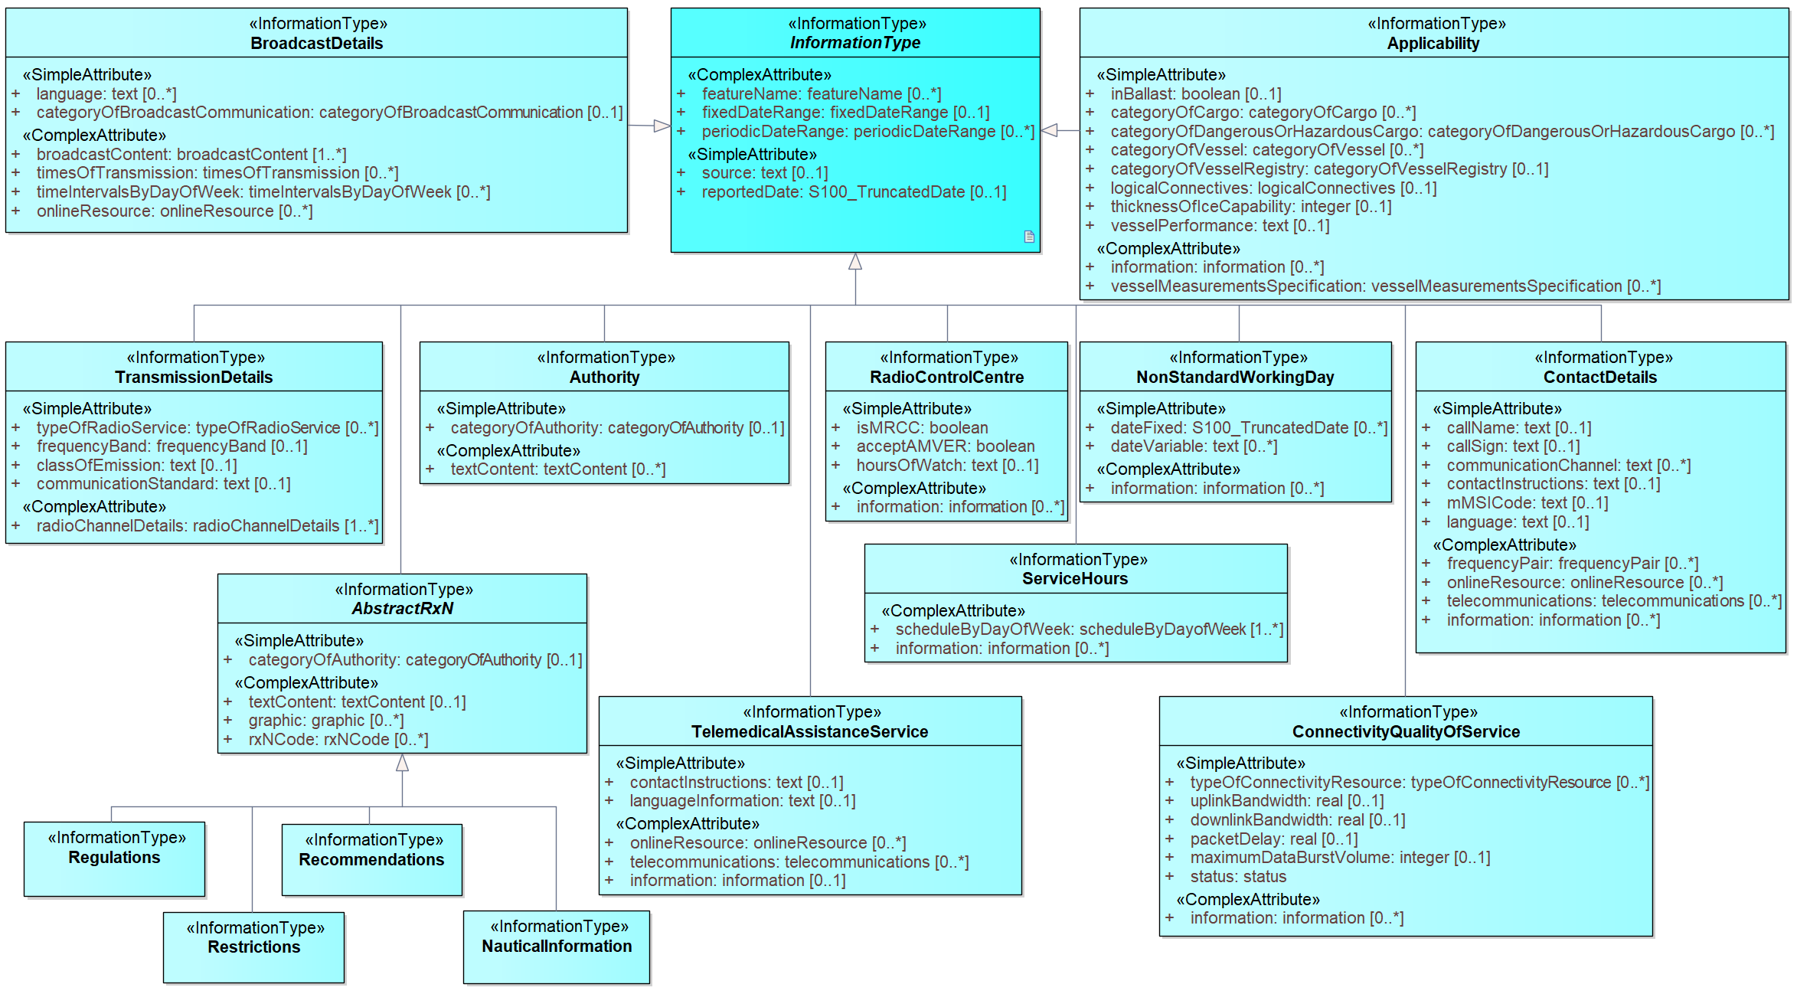
Figure 4-3. Overview of S-123 Information Types

The abstract class InformationType is an abstract class from which the information type classes in the S-123 domain model are derived. InformationType has attributes for fixed and periodic date ranges, name associated with the individual information object if any, and source information. The attributes defined in InformationType are inherited by all S-123 information type classes. All the attributes of InformationType are optional.

Radio stations and services
Marine radio stations and service areas are in general modeled by the RadioStation and RadioServiceArea features. MRCCs and MRSCs are modeled by the Boolean attribute isMRCC of RadioControlCenter information type.

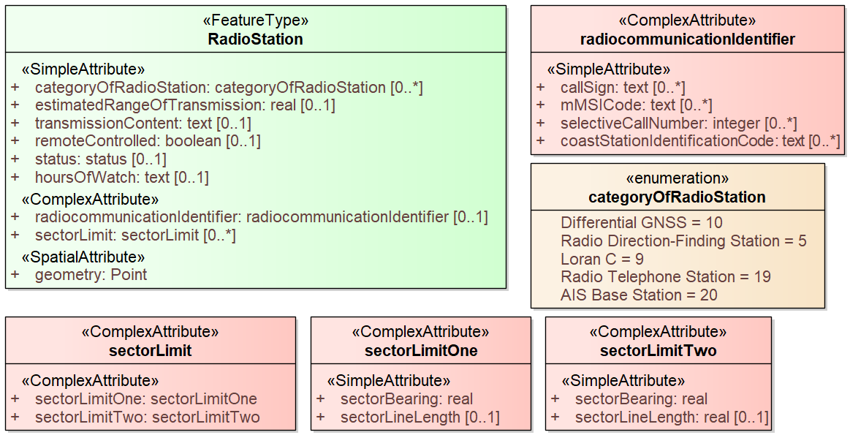
Figure 4-4. The RadioStation feature type
The IHO definition for the RadioStation feature type is “a place equipped to transmit radio waves…, and may also be provided with a radio receiver”. A radio station could be remote controlled, which is modeled by using the boolean type attribute remoteControlled of the RadioStation feature type and an association to a RadioControlCenter information object.

Detailed description of the radiocommunication service provision with respect to the radio method and radio channels is modeled by an associated TransmissionDetails information type (see Figure 4-5). Description of the content and schedule of the service using broadcast technology of radiocommunications is modeled by an associated BroadcastDetails information type (see Figure 4-6).
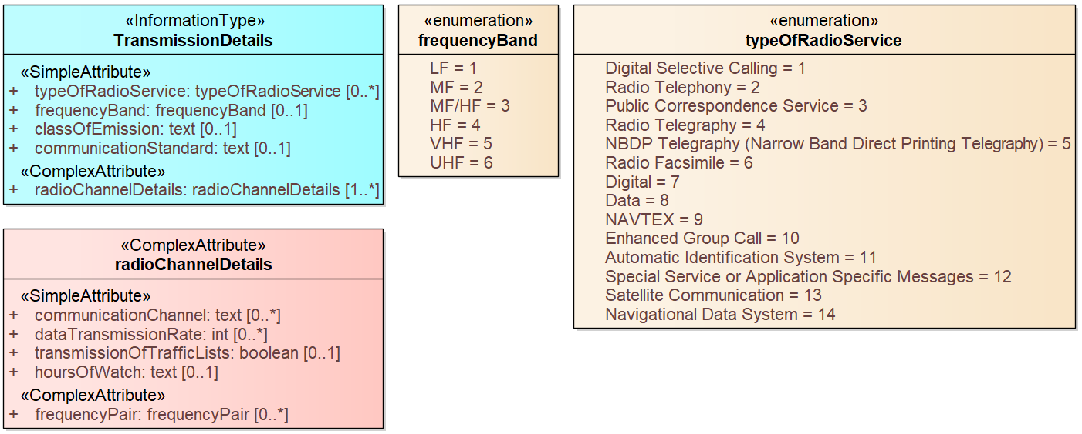
Figure 4-5. The TransmissionDetails information type
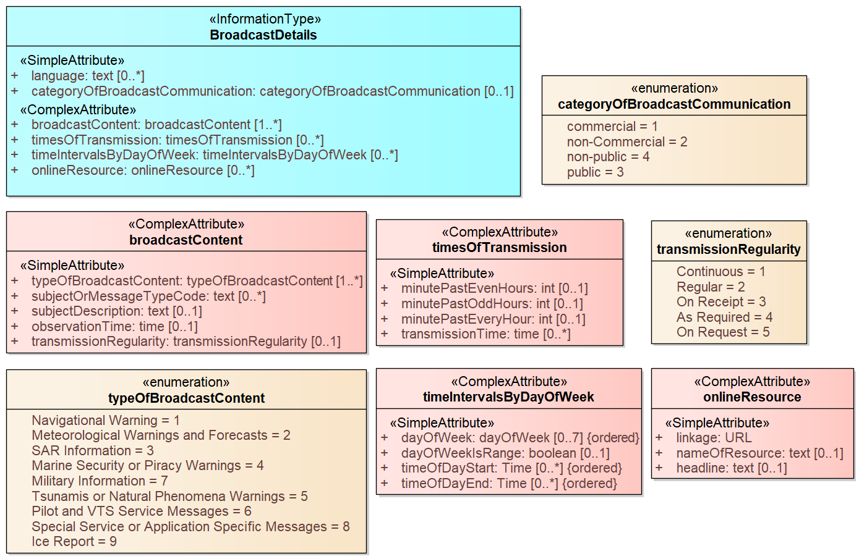
Figure 4-6. The BroadcastDetails information type
The S-123 model allows a radio service area to be encoded with or without the station from which the service is provided, and vice versa.

If a radio station and its service area(s) are both encoded, the relationship between them is modeled by the serviceProvisionArea feature association.

Additional information about the service operating schedule for the station or service as a whole is modeled by a locationHours association between the feature and a ServiceHours object. Similarly, contact information for the operator, control center or responsible authority of the station or service area as a whole is modeled using a srvContact association to a ContactDetails object.

Figure 4-7 shows the services which may have service times and operator/controller contact details encoded.

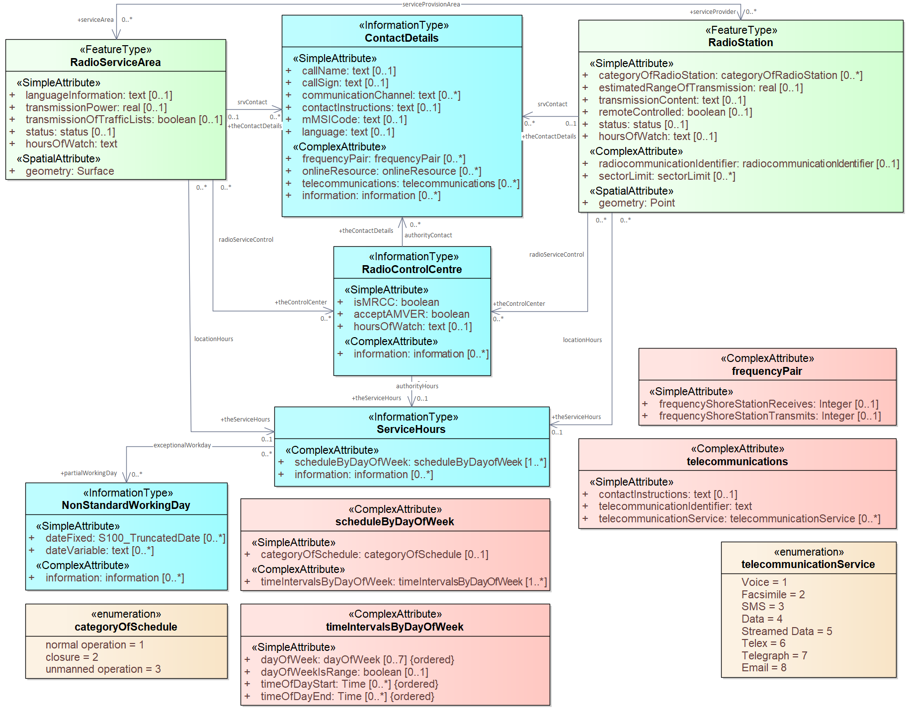
Figure 4-7 S-123 Radio service features with contact information and service hours

The ContactDetails class contains attributes describing the contact methods and identifiers for various contact methods for the operating or controlling authority, ranging from radiocommunications, to postal addresses. It is linked to the relevant instance of RadioServiceArea, RadioStation by the srvContact association, and to the RadioControlCenter by the authorityContact association.

ContactDetails may be repeated if an agency or office has more than one call name, call sign, or MMSI code. Other attributes such as communication channel, contact address, and telecommunications may be repeated within the same instance, e.g., if the contact could be made via multiple telecommunication services such as email, voice, and facsimile. Further instructions may be provided in the attribute contactInstructions.

If an operating schedule for the station or service area as a whole is to be encoded, it is done using an associated ServiceHours class, linked to the service feature by the locationHours association. Schedules that are specific to particular broadcasts from a radio station or within a single service area are modeled by means of attributes, e.g., timesOfTransmission and timeIntervalsByDayOfWeek, of associated BroadcastDetails information objects.

Indications about the specific controlling or responsible authority for a specific radio service area are provided by means of associations from the service feature to the Authority information type. All the service features in S-123 can be associated to a controlling or operating organization, i.e., an Authority object, using the controlAuthority association. The authority should be encoded only if its presence in the dataset conveys information that is useful to the end user.

If required, service hours and contact details of the authority may be provided by binding corresponding ServiceHours and ContactDetails information objects via the authorityHours association and authorityContact association, respectively. This is analogous to the case of RadioControlCenter illustrated in Figure 4-7.

Daily schedules and business hours
Operating schedules and business hours of organizations are modeled by associating the ServiceHours class to an Authority or RadioControlCenter. The ServiceHours class is a container for the complex attribute describing daily schedules for different weekdays (scheduleByDayOfWeek). This complex attribute contains another complex attribute for time intervals and the days to which they apply, and category sub-attribute to model whether the schedule describes opening hours, closures, etc. Exceptions to the schedule such as fixed or movable holidays are modeled by a NonStandardWorkingDay class with attributes allowing indication of the dates or days which are holidays or exceptions.

Working times and schedules for service features are modeled by an analogous association from the feature object (association locationHours). When a ServiceHours is thus linked to a service feature, the service hour information applies to the feature as a whole (e.g., all services offered by a RadioStation or in a RadioServiceArea). (See Figure 4-7)

The attribute hoursOfWatch is a simplified alternative to the ServiceHour information binding for common situations such as a 24 hour service. Attribute binding of hoursOfWatch is included in RadioStation, RadioServiceArea, and the radioChannelDetails attribute of TransmissionDetails.

Specific service area types
Figure 4-8 shows more specific types of service areas in S-123 domain model. Table 4.1 indicates the aspects of the service areas modelled in S-123.

To allow encoding of radio stations pertaining to more specific types of radio services, the serviceProvisionArea association is also permitted between more specific service area types and RadioStation. Both TransmissionDetails and BroadcastDetails information types may be associated not only to the radio station(s) but also to the various types of service area(s).
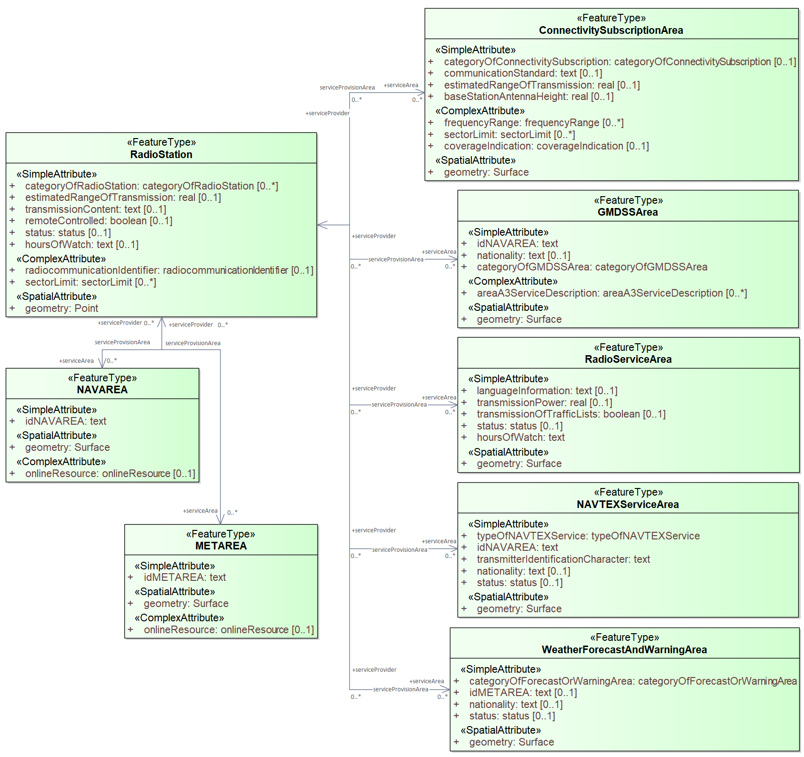
Figure 4-8 Service areas and provider(s)

Table 4.1 – Aspects of service areas modelled in S-123
S-123 Feature type | Responsible, intended, or declared service area | Radio coverage | Content coverage
RadioServiceArea
GMDSSArea
NAVAREA
METAREA
NAVTEXServiceArea
WeatherForecastAndWarningArea
ConnectivitySubsciptionArea

RadioServiceArea is a general-purpose service feature. With combination of attributes as well as associated BoardcastDetails and TransmissionDetails, RadioServiceArea may be used to encode radio services of various types and characteristics. (See Figure 4-9)

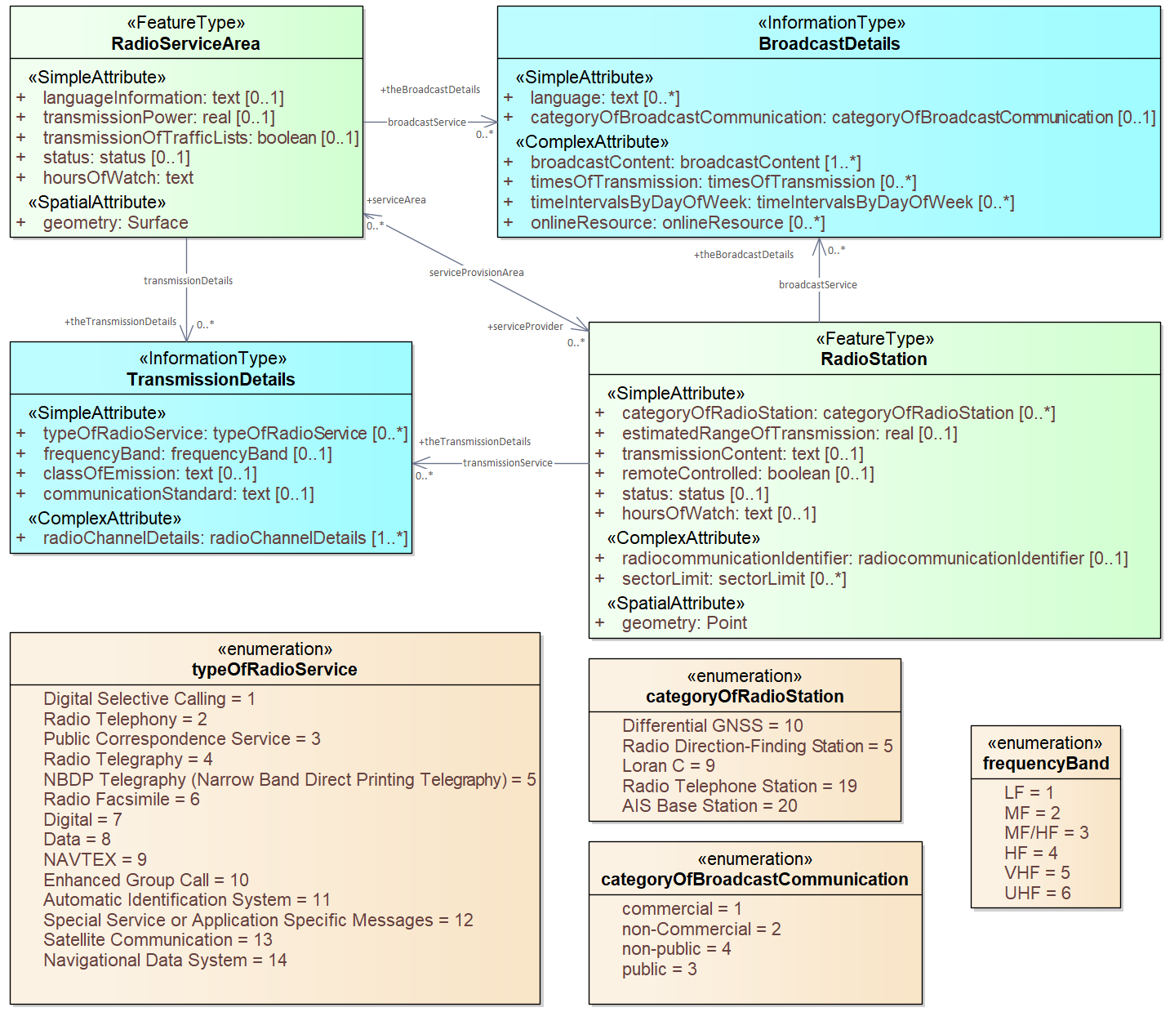
Figure 4-9 RadioServiceArea for encoding various type of services
When it is impractical to encode the radio coverage, e.g., in HF band, extent of the radio service may be encoded by using estimatedRangeOfTransmission attribute of RadioStation. Then, if required, encode the intended coverage area as a RadioServiceArea associated with the RadioStation, both features sharing the TransmissionDetails and BroadcastDetails. Maximum power (in Watt) the radio service uses or is authorized to use for radio transmission is encoded in the transmissionPower attribute of RadioServiceArea.

GMDSSArea is for encoding the GMDSS sea areas defined or designated by the government and where the government has established radiocommunication services for the GMDSS. (See Figure 4-10)

GMDSS sea areas also serve the purpose of defining the requirement of GMDSS radio installations onboard SOLAS vessels. The definition of sea area A3 in SOLAS convention has been revised (MSC.496(105)) as “an area, excluding sea areas A1 and A2, within the coverage of a recognized mobile satellite service (RMSS) supported by the ship earth station carried on board, in which continuous alerting is available.” Such mobile satellite service for sea area A3 may be encoded by using areaA3ServiceDescription attribute, in which satellite ocean region and MSI coastal warning areas (if applicable) may also be included with their identifiers.

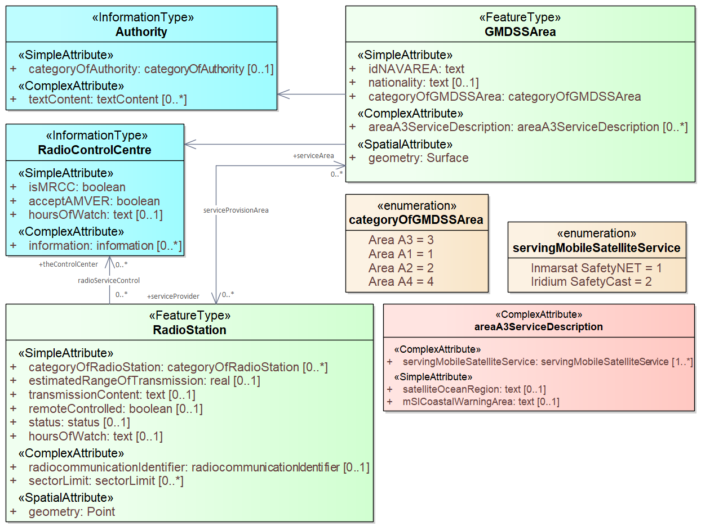
Figure 4-10 GMDSS sea areas and services
NAVAREA feature type is for encoding the NAVAREAs defined by IMO. NAVAREA link to the navigation warnings on the web may be provided using the onlineResource attribute.

In addition to idNAVAREA attribute, featureName (inherited from the abstract FeatureType) should also be encoded for identification of sub-area, such as Baltic Sea sub-Area.
NAVAREA or sub-area coordinator is encoded by associating Authority to NAVAREA. ContactDetails may be associated directly to NAVAREA. (See Figure 4-11)

Analogous to the case of NAVAREAs, METAREA feature type is for encoding the METAREAs defined by WMO. (See Figure 4-12)

WeatherForecastAndWarningArea feature type (see Figure 4-13) is for encoding an area for which weather forecasts and warnings are provided. Such areas may be defined by WMO or nationally by governments, thus categorized based on source of warnings and forecasts.

The area name may be encoded in the featureName (inherited from abstract FeatureType). The code or number of (NAVTEX or SafetyNET) forecast areas, to be referred to in MSI messages, should be encoded in forecastAreaIdentifier attribute.

Details of the service may be provided by using Authority, RadioStaion, BroadcastDetails and TransmissionDetails associated to the WeatherForecastAndWarningArea feature.

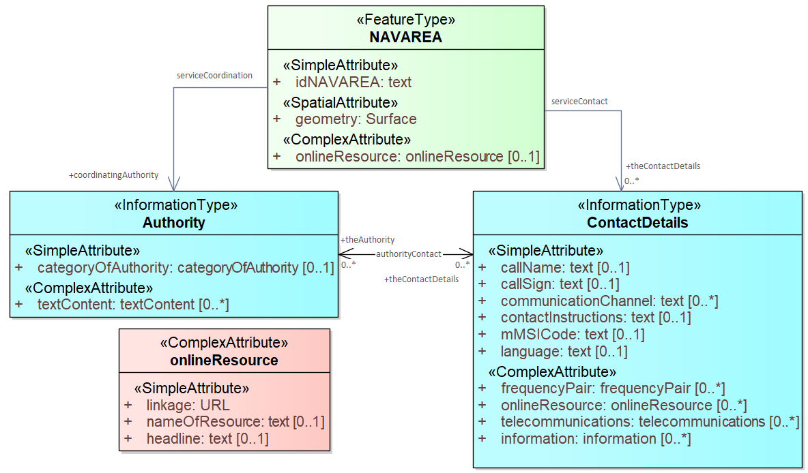
Figure 4-11 NAVAREA and the coordinator

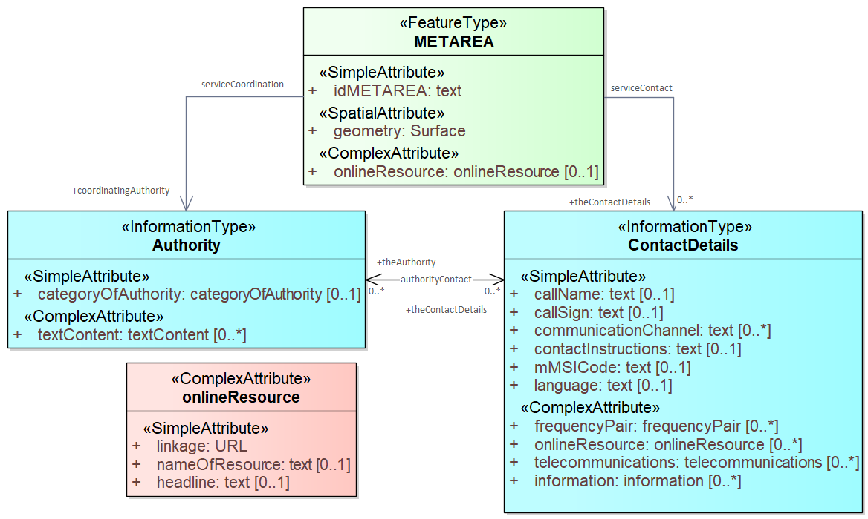
Figure 4-12 METAREA and the coordinator

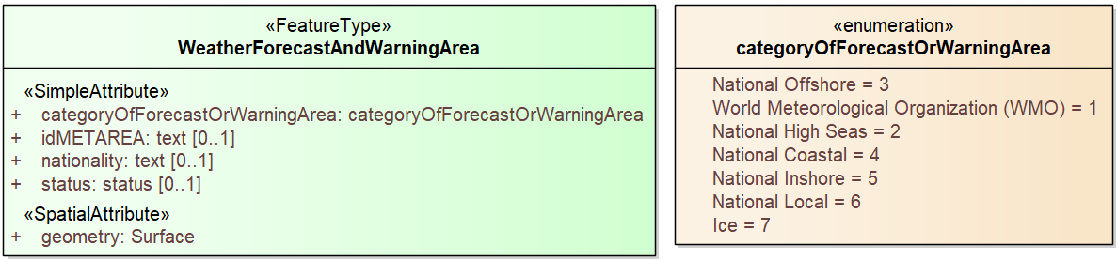
Figure 4-13 Weather forecast and warning area
S-123 models NAVTEX service based on definitions in the Joint IMO/IHO/WMO Manual on Maritime Safety Information (MSC.1/Circ.1310/Rev.2 or IHO S-53), as follows:

- “NAVTEX service area means a unique and precisely defined sea area, wholly contained within the NAVTEX coverage area, for which maritime safety information is provided from a particular NAVTEX transmitter.”.
- “NAVTEX coverage area means an area defined by an arc of a circle having a radius from the transmitter calculated according to the method and criteria given in IMO resolution A.801(19), as amended.”.
- “Broadcast times for NAVTEX are defined by the (allocated) B1 transmitter identification character of the station.”

NAVTEXServiceArea uses idNAVAREA and transmitterIdentificationCharacter to uniquely identify a NAVTEX service area and allocated time slots (for transmission from the associated RadioStation). Schedule of different types of broadcast content may be encoded in the associated BroadcastDetails. Encoding of national NAVTEX service in national language and different radio channel is also supported by using typeOfNAVTEXService, nationality, radioChannelDetails, and language. (See Figure 4-14)

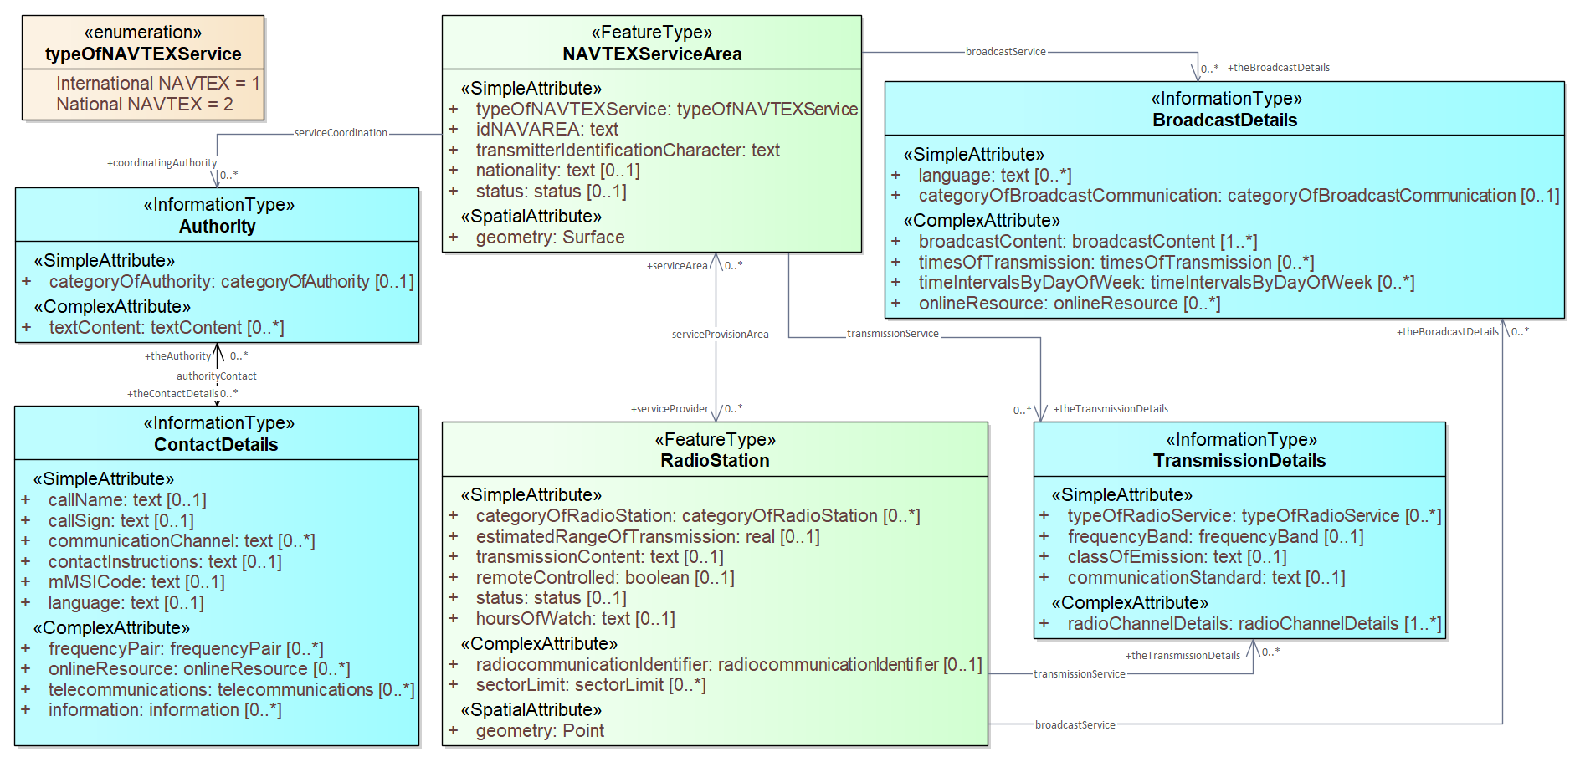
Figure 4-14 NAVTEX service area
NAVTEX coverage area is indicated by the associated RadioStation and its estimatedRangeOfTransmission attribute. If required, RadioServiceArea may also be used to define the radio coverage area of NAVTEX service. BroadcastDetails and TransmissionDetails (with typeORadioService=9 (NAVTEX)), should be shared by relevant features.
ConnectivitySubscriptionArea feature type is for encoding an area of connectivity coverage available for the subscription of IP-connectivity service. Provide relevant information in the associated ConnectivityQualityOfService, Authority and ContactDetails. Name of the service or company should be entered in the featureName (inherited attribute) of relevant objects. (See Figure 4-15)

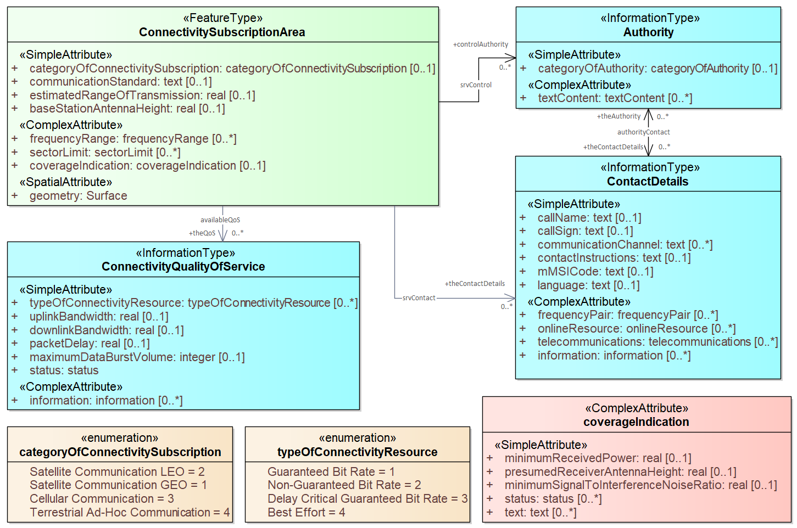
Figure 4-15 Connectivity subscription area

SAR and Telemedical Assistance Service
SearchAndRescueRegion feature type and TelemedicalAssistanceService information type are for encoding the Search and Rescue (SAR) responsibility regions or sub-regions, the associated Rescue Coordination Center (Maritime Rescue Coordination Centre or sub-Centre), as well as the available Telemedical Assistance Service (TMAS) and SAR service. (See Figure 4-16)

Radionavigation Service such as DGNSS
In this edition of S-123, radionavigation services are modelled in a generic way mainly by using RadioStation, TransmissionDetails, BroadcastDetails. A RadioServiceArea may also be associated, if the coverage geometry is required.

For a beacon DGNSS station, the transmitting station ID should be encoded in the sub-attribute coastStationIdentificationCode of radiocommunicationIdentifier. The transmission frequency, frequencyBand (MF), dataTransmissionRate, communicationStandard (ITU-R M.823-3), classOf Emission (G1D) may be encoded in the associated TransmissionDetails. Transmitted DGNSS message types may be described in the transmissionContent attribute of RadioStation or encoded by using the subjectOrMessageTypeCode of an associated BroadcastDetails. (See 4.2.1.2 for related data models)

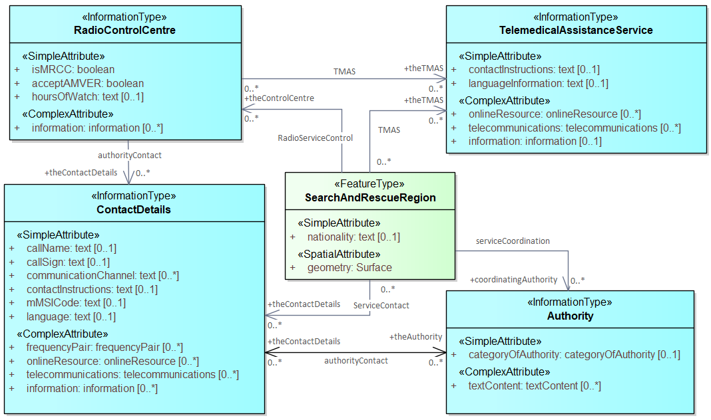
Figure 4-16 Search and Rescue Region and Telemedical Assistance Service

Regulations, information notes, etc.
There are three information types which represent regulations, restrictions, and recommendations respectively, and a fourth information type for general or unclassifiable information.
- The Regulations class represents information derived from laws, national shipping regulations, navigation rules, etc.
- Class Restrictions is intended for restrictions that are not derived from regulatory sources.
- Class Recommendations is intended for information that is recommendatory in nature; in S-123 this may be recommendations for maintenance of listening watches, AMVER reporting, etc., that are either voluntary or have not been issued as formal regulations.
- The fourth class, NauticalInformation, is intended for general notes or other information that cannot be categorized as one of the other three classes.

These four information types will hereafter be referred to collectively as RxN, which all inherit the attributes of their immediate abstract superclass AbstractRxN. AbstractRxN provides attributes textContent and graphic for textual and pictorial material respectively. The sub-attributes of its complex attribute rxNCode allow optional classification of the material encoded in textContent/graphic according to the type of material and the kind of nautical activity affected by it. RxN information types also inherit attributes of abstract superclass InformationType, which allows encoding of the effective and expiry dates, if any, and source of information, if it is necessary to encode that data. (See Figure 4-16)

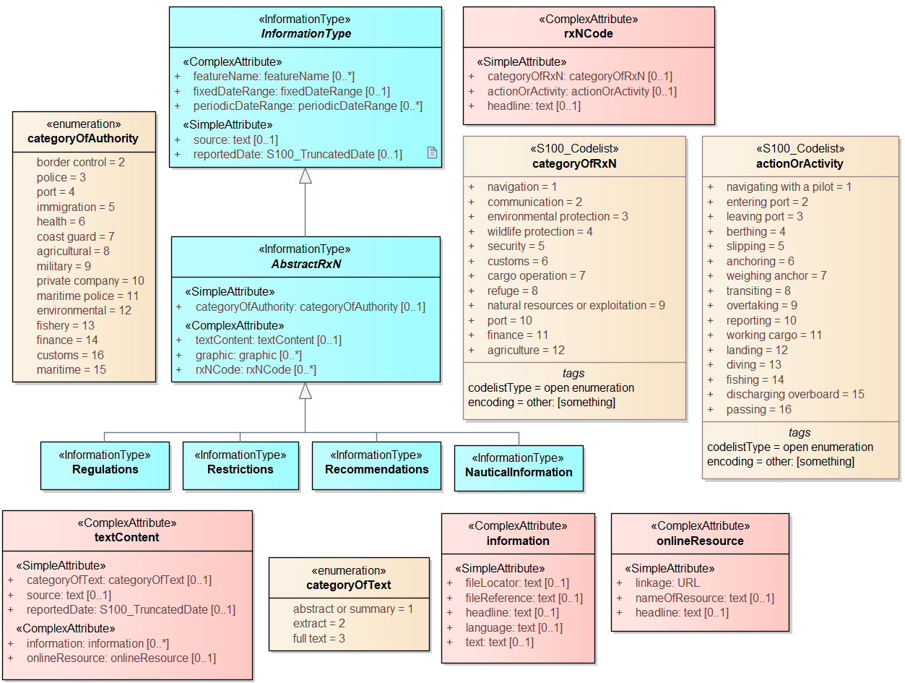
Figure 4-17. Structure of regulations and note information types

Regulations applying in specific geographic features
RxN classes are intended primarily for encoding text information, such as that derived from textual source material, e.g., national or local laws or official publications. Where specific attributes such as the simple attribute restriction are permitted, they must be used. For example, if a geographic feature class has the restriction attribute, it should be used instead (explanations, details, paragraphs from regulations, etc., can be provided in an associated RxN object).

The associatedRxN association between a feature type and a Regulations, Restrictions, Recommendations, or NauticalInformation object indicates that the Regulation, etc., is applicable within the associated feature. If it is necessary to identify an authority or organization related to a particular regulation (restriction, etc.) object, this may be done using the relatedOrganisation association between Regulations, etc., and an Authority object. This should be included only when the connection to the Authority conveys useful information to the end user – it is not intended to encode the issuing or controlling authority for every regulation. Note also that while Authority can be associated to geographic features as well as Regulations, etc., encoding both associations is not mandatory even when the same Authority is associated to a service area as well as a Regulations object (or NauticalInformation, etc.).

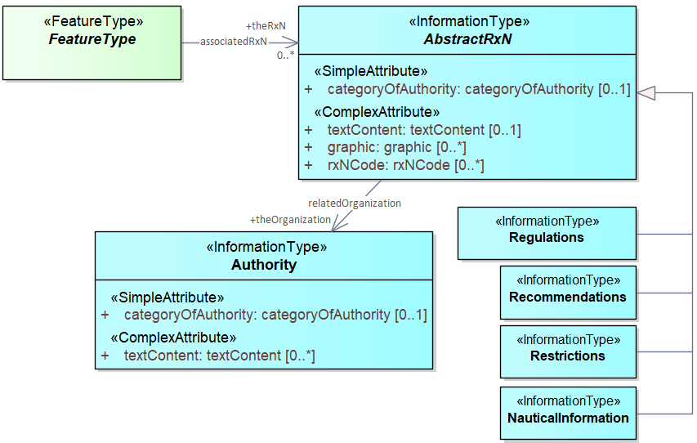
Figure 4-18. Regulations, etc., relevant to specific features

Regulations applying only to vessels with specific characteristics or cargoes
Certain regulations apply only to vessels of specified dimensions, types, or carrying specified cargo, etc.

This is modelled by first defining the relevant subset of vessels according to the dimension, type, cargo, etc., and then associating that subset to the appropriate feature or information type. The subset of vessels is modelled using the Applicability class, which contains attributes for the most common vessel characteristics used in nautical publications. These include measurements (length, beam, draught), type of cargo, displacement, etc. Constraints which cannot be modeled using the attributes of Applicability can be described in plain text in its information attribute.

Conditions relating to vessel dimensions are modelled by the complex attribute vesselsMeasurements, which has sub-attributes for naming the dimension and indicating the limit (whether the condition applies to a vessel which exceeds or falls below the limit). For example, the combinations below describe the condition “length overall > 50 m” (Condition 1) and “length overall < 90 m” (Condition 2):

 | Condition 1 | Condition 2 | Condition 3
vesselsCharacteristics | length overall | length overall | breadth
vesselsCharacteristicsUnit | metre | metre | metre
comparisonOperator | greater than | less than | greater than
vesselsCharacteristicsValue | 50 | 90 | 20
Table 4.2 - Conditions relating to vessel dimensions

The logicalConnectives attribute is used to indicate how to interpret the case where multiple conditions are encoded using attributes of measurements - whether the conditions described by condition attributes are cumulative (conjunctive, AND) or alternatives (disjunctive, OR). A logicalConnectives=AND combined with Conditions 1 and 2 above describes a vessel of length between 50 and 90 metres; logicalConnectives=OR combined with conditions 1 and 3 describes a vessel of length greater than 50 metres or beam greater than 20 metres.

This modeling cannot represent subsets defined by both AND and OR combinations of conditions, but it is always possible to convert such complex conditions into multiple combinations each using only AND (‘conjunctive normal form’) or OR (‘disjunctive normal form’), and model the subset using more than one Applicability object.

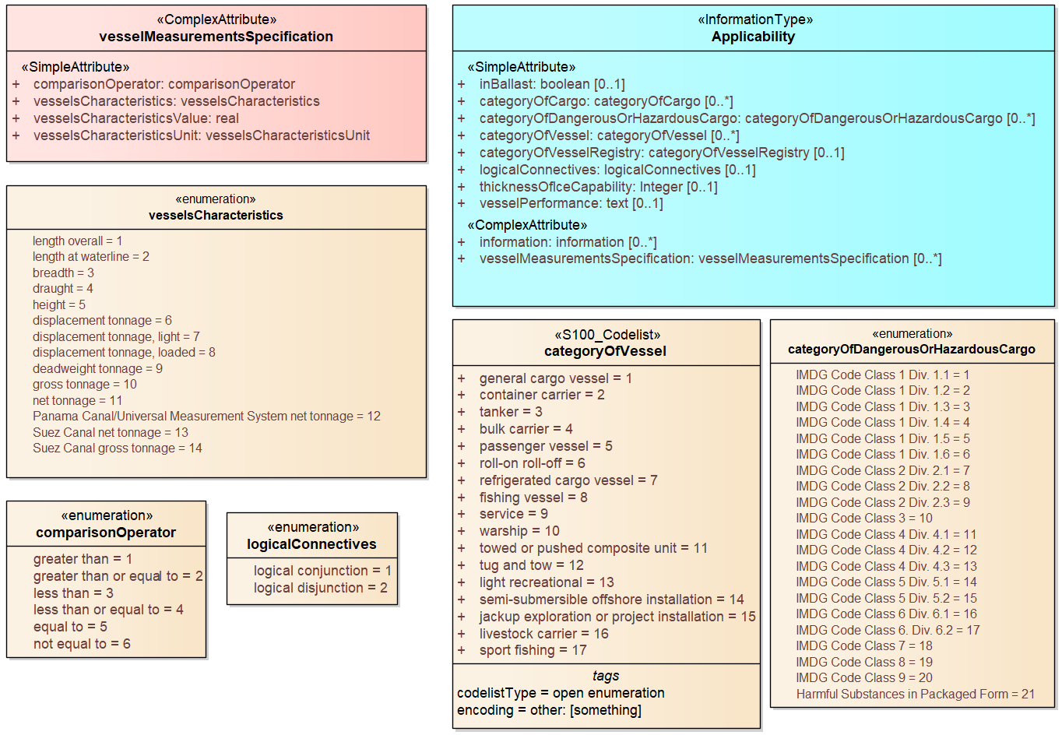
Figure 4-19. Vessel subsets characterized by cargo and dimensions
Given the relevant subset of vessels, it can be associated to the appropriate feature, regulation, or report by a PermissionType, or InclusionType association. These are association classes, whose single attribute models the nature of the relationship between the vessel subset and feature or information type.
The association classes PermissionType and InclusionType basically characterize the relationship. For example, a specified set of vessels is COVERED by a regulation and another set of vessels is EXEMPT from the regulation.

“COVERED” and “EXEMPT” are different kinds of relationship between different subsets of vessels characterized by different dimensional limits, etc., and a given regulation.
“MUST use”, “RECOMMENDED to use”, and “EXEMPT from use” are relationships between different subsets of vessels characterized by different dimensional limits, etc., and a given feature or service.
PermissionType links a feature to an Applicability, and models a requirement, recommendation or prohibition on using a (service) feature, by the specified subset of vessels.
InclusionType links a Regulation, Recommendation, Restriction, or NauticalInformation instance to a subset defined by an Applicability object, and indicates whether the content of the Regulation, etc., applies to the vessels (membership=included), or explicitly does not apply to the vessels (membership=excluded).

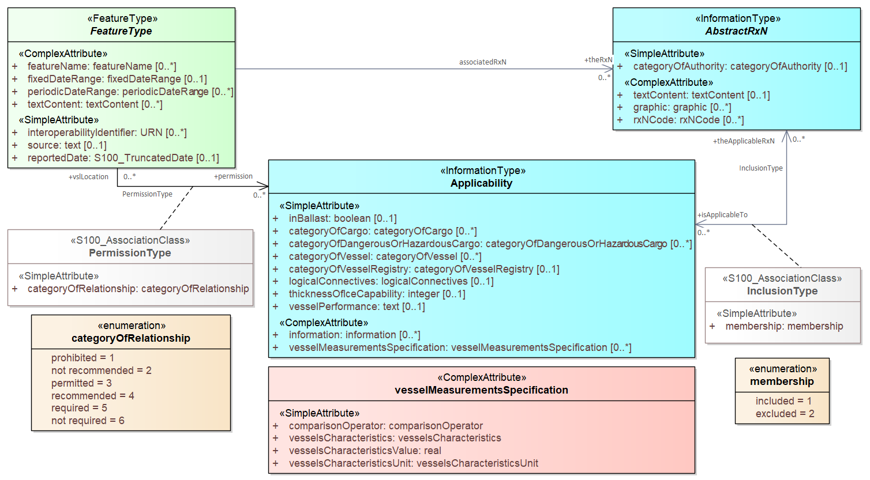
Figure 4-20. Applicability of requirements, rules, etc. to vessel categories

Fuzzy areas in the S-123 application schema
Fuzzy areas are areas where the applicability of information described by a specific feature is uncertain, intermittent, or possible. The basic information concept can be the availability of a service, the existence of a natural phenomenon, etc. An example is an area where radio reception cannot be asserted with sufficiently high confidence to encode it as a definitely within the service area, but reception is sometimes or often possible under good conditions. Associating uncertainty values to boundary points is not sufficient for this concept.

Areas of uncertainty are modeled by an IndeterminateZone geographic feature. A ‘fuzzy area’ will therefore consist of a ‘core’ feature of the appropriate geographic feature type and the appropriate geometry (e.g., a RadioServiceArea area feature) and one or more ‘fuzzy’ Indeterminate Zone features (with surface geometry). Each IndeterminateZone feature has a thematic attribute expressing the level of confidence that the service described by the core feature will be available in the region demarcated by its spatial primitive(s). To provide for properties of the collection of core and fuzzy features (e.g., a collective name for the totality of core and fuzzy areas), an abstract aggregation feature is defined, associated to the indeterminate zone features. This abstract aggregation feature is sub-classed by type-specific aggregation features corresponding to the geographic feature types which can be fuzzy. Type-specific attributes for aggregates can be added to these features.

S-123 modeling of fuzzy areas is used for radio service area features. S-123 uses the generic model of fuzzy areas described above and subclasses the abstract FuzzyAreaAggregate class into the aggregate class RadioServiceAreaAggregate.

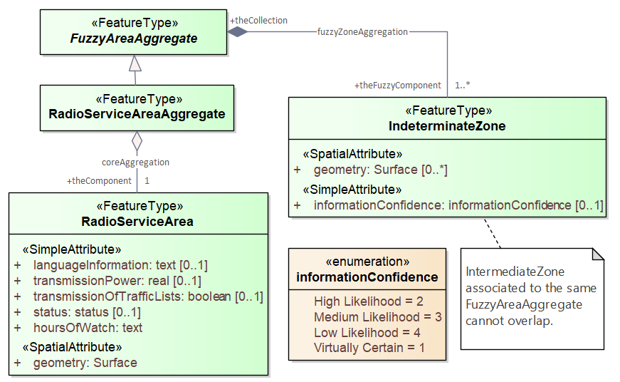
Figure 4-21. Fuzzy areas in S-123

Uncategorized additional information
The domain model also provides a method for attaching to any feature or information type data in the form of a text note, graphic, or Internet reference which cannot be categorized using an appropriate specific feature or information type. This consists of defining a NauticalInformation object and referencing it from the feature or information type using the additionalInformation association.

This method is intended to be a last resort and every effort should be made to use a more specific feature or information type to encode the information to be attached, including splitting the information in question across more than one type of feature or information object as needed and/or using the associatedRxN association instead of additionalInformation, wherever the nature of the content allows it.

The additionalInformation association must not be used to chain NauticalInformation, Regulations, Restrictions, or Recommendations objects, whether they are of the same class or different classes.

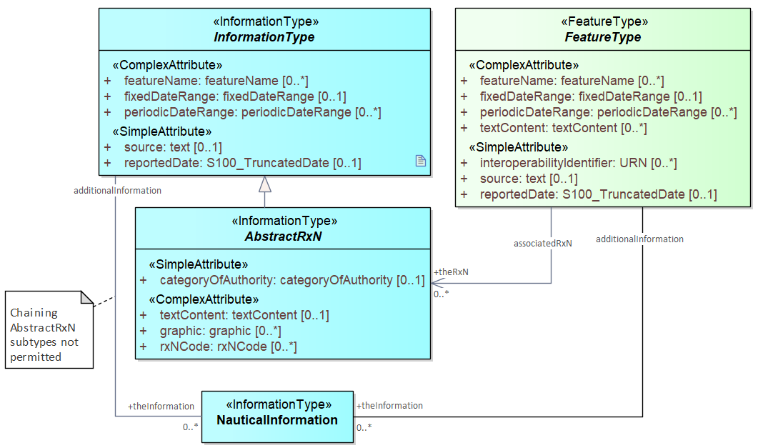
Figure 4-22 Attachment of uncategorized information to any feature or information type

Meta features
S-123 has two meta feature classes. One is QualityOfNonbathymetricData, the other is DataCoverage.

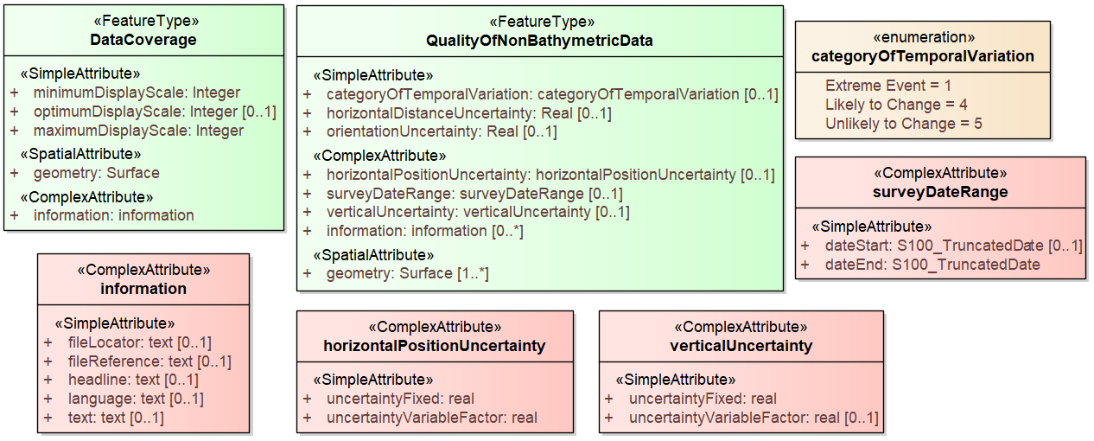
Figure 4-23. Overview of Meta feature classes

Spatial quality information type

S-123 spatial quality attributes are carried in an information type called SpatialQuality. The attributes are for qualitative horizontal measurement quality and quantitative spatial accuracy. (See Figure 4-23)

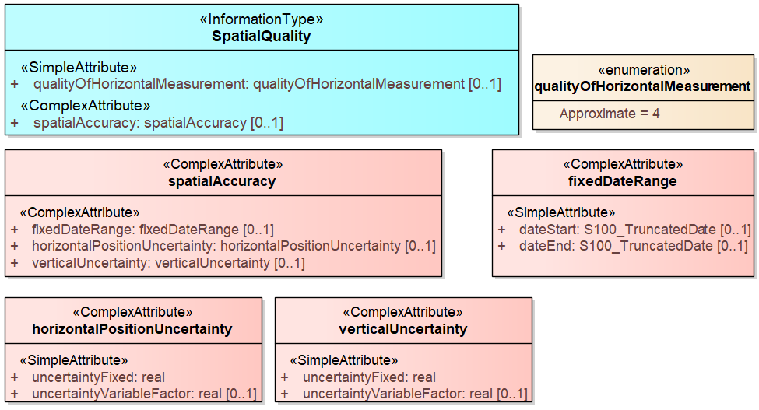
Figure 4-24. Spatial quality

Feature catalogue

Introduction
The Feature Catalogue describes the feature types, information types, attributes, attribute values, associations and roles which may be used in the product. The S-123 Feature Catalogue is available in an XML document which conforms to the S-100 XML Feature Catalogue Schema and can be downloaded from the IHO website (http://www.iho.int/).

Feature types
Feature types contain descriptive attributes that characterize real-world entities. The word ‘feature’ may be used in one of two senses – feature type and feature instance. A feature type is a class and is defined in a Feature Catalogue. A feature instance is a single occurrence of the feature type and represented as an object in a dataset. A feature instance is located by a relationship to one or more spatial instances. A feature instance may exist without referencing a spatial instance.

Geographic
Geographic (geo) feature types carries the descriptive characteristics of a real-world entity (a location or place on the surface of the Earth). In the context of hydrographic products, this includes the adjacent regions from the sea floor to elevations of landforms and structures above the Earth’s surface.

Meta
Meta features contain information about other features within a dataset. Information defined by meta features override the default metadata values defined by the dataset descriptive records. Meta attribution on individual features overrides attribution on meta features.

Cartographic
Cartographic features contain information about the cartographic representation (including text) of real world entities. Cartographic feature types are not used in S-123.

Information Types
Information types are identifiable pieces of information in a dataset that can be shared between other features. They have attributes but have no relationship to any geometry; information types may reference other information types.

Feature and information relationships
A feature relationship links instances of one feature type with instances of the same or a different feature type.
An information relationship links instances of feature types or information types to instances of information types.

Attributes
S-123 defines attributes as either simple or complex.

Simple Attributes
The types of simple attributes used in S-123 are listed in Annex A – Data Classification and Encoding Guide. Descriptions of the simple attributes included in S-123 can also be found in Annex A.

Complex Attributes
Complex attributes are aggregations of other attributes that are either simple or complex. The aggregation is defined by means of attribute bindings.

Geometric Representation
Geometric representation is the digital description of the spatial component of an object as described in S-100 and ISO 19107. This product specification uses two types of geometries: GM_Point and GM_Surface.

Coordinate Reference System (CRS)

Horizontal Coordinate Reference System
The coordinate reference system used for this product specification is World Geodetic System 1984 (WGS 84) which is defined by the European Petroleum Survey Group (EPSG) code 4326.

Projection
Datasets conforming to this product specification are not projected.

Temporal reference system
Time is measured by reference to Calendar dates and Clock time in accordance with ISO 19108:2002 Temporal Schema clause 5.4.4.

Geometry

S-123 geometry
Marine Radio Services (MRS) features are encoded as vector entities which conform to S-100 geometry configuration level 3a (S-100 clause 7-4.3).
Level 3a is a set of point, curve and surface primitives with the following constraints:
- Each curve must reference a start and end point (they may be the same).
- Curves must not self-intersect. See S-100 Figure 7-5.
- Areas are represented by a closed loop of curves beginning and ending at a common point.
- In the case of areas with holes, all internal boundaries must be completely contained within the external boundary and the internal boundaries must not intersect each other or the external boundary. Internal boundaries may touch other internal boundaries or the external boundary tangentially (that is at one point) as shown in S-100 Figure 7-6.
- The outer boundary of a surface must be in a clockwise direction (surface to the right of the curve) and the curve orientation positive. The inner boundary of a surface must be in a counter-clockwise direction (surface to the right of the curve) and the curve orientation negative. See S-100 Figure 7-7.
S-123 further constrains Level 3a with the following:
- Coincident linear geometry must be avoided when there is a dependency between features.
- The interpolation of GM_CurveSegment must be loxodromic.
- Linear geometry is defined by curves which are made of curve segments. Each curve segment contains the geographic coordinates as control points and defines an interpolation method between them. Coordinate density can have a significant impact on file size and system performance. A rule of thumb is to limit the coordinate density to 0.3 mm at maximum permitted display scale.
- For a scale-less product, the producer should keep in mind the expected scale range for typical use and the density of coordinates needed to suit the needs of the product.
The following exception applies to S-123:
- The use of coordinates is restricted to two dimensions (DirectPosition is restricted to two coordinates).

MRS data and scale
MRS data must be compiled in the best applicable scale. The use of the data itself is "scale independent". That means that the data can be used at any scale.

Coordinate encoding in spatial primitives
Geometry may be encoded either inline or by reference to a spatial primitives located elsewhere in the dataset that encodes the actual coordinate values. The GML conventions for references and axis order must be followed.
The CRS shall be EPSG code 4326 and identified using the http URI convention for SRS specified by OGC, which is http://www.opengis.net/def/crs/EPSG/0/4326” (Quote S-100 Ed.5.2.0 10b-11.7). The axis order is latitude/longitude.

Data Quality

Introduction
Data quality allows users and user systems to assess fitness for use of the provided data. Data quality measures and the associated evaluation are reported as metadata of a data product. This metadata improves interoperability with other data products and provides scope for usage by user groups that the data product was not originally intended for. The secondary users can make assessments of the data product usefulness in their application based on the reported data quality measures.
For S-123 the following data quality elements have been included:
- Conformance to this Product Specification;
- Intended purpose of the data product;
- Completeness of the data product in terms of coverage;
- Logical consistency;
- Positional uncertainty and accuracy;
- Thematic accuracy;
- Temporal quality;
- Aggregation measures;
- Validation checks or conformance checks including:
- General tests for dataset integrity; and
- Specific tests for compliance against the S-123 data model.

Quality measure elements
The data quality measures recommended in S-97 (Part C) and their applicability in S-123 are indicated in Table 5.1 below. NA indicates the measure is not applicable. This table reproduces the first 4 columns of the data quality checklist recommended elements and replaces the final column with descriptions of the scope of the element in the context of S-123 datasets.
Table 5.1 - Quality measure elements
No. | Data quality element and sub element | Definition | DQ measure / description | Evaluation scope | Scope in S-123
1 | Completeness / Commission | Excess data present in a dataset, as described by the scope. | numberOfExcessItems / This data quality measure indicates the number of items in the dataset, that should not have been present in the dataset. | dataset/dataset series | All features and information types
2 | Completeness / Commission | Excess data present in a dataset, as described by the scope. | numberOfDuplicateFeatureInstances / This data quality measure indicates the total number of exact duplications of feature instances within the data. | dataset/dataset series | All features and information types
3 | Completeness / Omission | Data absent from the dataset, as described by the scope. | numberOfMissingItems / This data quality measure is an indicator that shows that a specific item is missing in the data. | dataset/dataset series/ spatial object type | All features and information types
4 | Logical Consistency / Conceptual Consistency | Adherence to the rules of a conceptual schema. | numberOfInvalidSurfaceOverlaps / This data quality measure is a count of the total number of erroneous overlaps within the data. Which surfaces may overlap and which must not is application dependent. Not all overlapping surfaces are necessarily erroneous. | spatial object / spatial object type | Features with surface geometry; spatial objects of type surface
5 | Logical Consistency / Domain Consistency | Adherence of the values to the value domains. | numberOfNonconformantItems / This data quality measure is a count of all items in the dataset that are not in conformance with their value domain. | spatial object / spatial object type | All features and information types
6 | Logical Consistency / Format Consistency | Degree to which data is stored in accordance with the physical structure of the dataset, as described by the scope | physicalStructureConflictsNumber / This data quality measure is a count of all items in the dataset that are stored in conflict with the physical structure of the dataset. | dataset/dataset series | All features and information types
7 | Logical Consistency / Topological Consistency | Correctness of the explicitly encoded topological characteristics of the dataset, as described by the scope. | rateOfFaultyPointCurveConnections / This data quality measure indicates the number of faulty link-node connections in relation to the number of supposed link-node connections. This data quality measure gives the erroneous point-curve connections in relation to the total number of point-curve connections. | spatial object / spatial object type | NA S-123 does not use curve type geometry.  Features with curve geometry; spatial objects of curve types
8 | Logical Consistency / Topological Consistency | Correctness of the explicitly encoded topological characteristics of the dataset, as described by the scope. | numberOfMissingConnectionsUndershoots / This data quality measure is a count of items in the dataset within the parameter tolerance that are mismatched due to undershoots. | spatial object / spatial object type | NA S-123 does not use curve type geometry.  Features with curve geometry; spatial objects of curve types
9 | Logical Consistency / Topological Consistency | Correctness of the explicitly encoded topological characteristics of the dataset, as described by the scope. | numberOfMissingConnectionsOvershoots / This data quality measure is a count of items in the dataset within the parameter tolerance that are mismatched due to overshoots. | spatial object / spatial object type | NA S-123 does not use curve type geometry.  Features with curve geometry; spatial objects of curve types
10 | Logical Consistency / Topological Consistency | Correctness of the explicitly encoded topological characteristics of the dataset, as described by the scope. | numberOfInvalidSlivers / This data quality measure is a count of all items in the dataset that are invalid sliver surfaces. A sliver is an unintended area that occurs when adjacent surfaces are not digitized properly. The borders of the adjacent surfaces may unintentionally gap or overlap to cause a topological error. | dataset / dataset series | Features with surface geometry; spatial objects of type surface
11 | Logical Consistency / Topological Consistency | Correctness of the explicitly encoded topological characteristics of the dataset, as described by the scope. | numberOfInvalidSelfIntersects / This data quality measure is a count of all items in the dataset that illegally intersect with themselves. | spatial object / spatial object type | Features with surface geometry; spatial objects of type surface or curve  S-123 does not use curve type geometry.
12 | Logical Consistency / Topological Consistency | Correctness of the explicitly encoded topological characteristics of the dataset, as described by the scope. | numberOfInvalidSelfOverlap / This data quality measure is a count of all items in the dataset that illegally self-overlap. | spatial object / spatial object type | Features with surface geometry; spatial objects of type surface or curve  S-123 does not use curve type geometry
13 | Positional Accuracy / Absolute or External Accuracy | Closeness of reported coordinative values to values accepted as or being true. | Root Mean Square Error / Standard deviation, where the true value is not estimated from the observations but known a priori. | spatial object / spatial object type | objects that have coordinative values associated.
14 | Positional Accuracy / Vertical Position Accuracy | Closeness of reported coordinative values to values accepted as or being true. | linearMapAccuracy2Sigma / Half length of the interval defined by an upper and lower limit in which the true value lies with probability 95%. | spatial object / spatial object type | N/A S-123 does not use 3-D coordinates..
15 | Positional Accuracy / Horizontal Position Accuracy | Closeness of reported coordinative values to values accepted as or being true. | linearMapAccuracy2Sigma / Half length of the interval defined by an upper and lower limit in which the true value lies with probability 95%. | spatial object / spatial object type | objects that have a horizontal coordinate values associated.
16 | Positional Accuracy / Gridded Data Position Accuracy | Closeness of reported coordinative values to values accepted as or being true. | Root mean square error of planimetry / Radius of a circle around the given point, in which the true value lies with probability P. | spatial object / spatial object type | NA. S-123 does not have features with gridded geometry
17 | Temporal Quality / Temporal Consistency | Consistency with time. | Correctness of ordered events or sequences, if reported. | dataset/dataset series/ spatial object type | Features with time intervals, fixed/periodic date ranges, schedules.
18 | Thematic Accuracy / ThematicClassificationCorrectness | Comparison of the classes assigned to features or their attributes to a universe of discourse. | miscalculationRate / This data quality measure indicates the number of incorrectly classified features in relation to the number of features that are supposed to be there. [Adapted from ISO 19157]  This is a RATE which is a ratio, and is expressed as a REAL number representing the rational fraction corresponding to the numerator and denominator of the ratio.  For example, if there are 1 items that are classified incorrectly and there are 100 of the items in the dataset then the ratio is 1/100 and the reported rate = 0.01. | dataset/dataset series/ spatial object type | All features and info types
19 | Aggregation Measures / AggregationMeasures | In a data product specification, several requirements are set up for a product to conform to the specification. | DataProductSpecificationPassed / This data quality measure is a boolean indicating that all requirements in the referred data product specification are fulfilled. | dataset/dataset series/ spatial object type | Dataset as a whole
20 | Aggregation Measures / AggregationMeasures | In a data product specification, several requirements are set up for a product to conform to the specification. | DataProductSpecificationFailRate / This data quality measure is a number indicating the number of data product specification requirements that are not fulfilled by the current product/dataset in relation to the total number of data product specification requirements. | dataset/dataset series/ spatial object type | Dataset as a whole

Completeness

Commission
Commission is applicable for S-123. Data Producers must verify that no excess items have been included in the dataset. This includes duplicate items, which must be removed.
IHO Publications S-158:100 – S-100 Validation Checks and/or S-158:123 – S-123 Validation Checks, include data validation check(s) intended to identify excess and/or duplicate items.
If no excess or duplicate items are present the dataset PASSES this test.

Omission
Omission is applicable for S-123. Data Producers must verify that no items that should have been included in the dataset have been missed. This includes missing features specified as mandatory in S-123; and missing support files referenced by the dataset.
IHO Publications S-158:100 – S-100 Validation Checks and/or S-158:123 – S-123 Validation Checks, include data validation check(s) intended to detect missing items.
If no items have been omitted the dataset PASSES this test.

Logical consistency

Conceptual consistency
Conceptual Consistency is applicable for S-123 and follows the guidelines from S-100 Part 1 - Conceptual Schema Language.
Data Producers must verify that the dataset conforms to the S-100 General Feature Model. IHO Publications S-158:100 – S-100 Validation Checks and/or S-158:123 – S-123 Validation Checks, provide validation checks which verify this conformance.
If no conceptual consistency checks classified as Critical in S-158:100 or S-158:123 are reported the dataset PASSES this test.

Domain consistency
Domain consistency is applicable for S-123 and follows the guidelines from S-100 Part 5 – Feature Catalogue.
Data Producers must verify that the dataset conforms to the S-123 Feature Catalogue and rules described in S-123 Annex A – Data Classification and Encoding Guide. IHO Publications S-158:100 – S-100 Validation Checks and/or S-158:123 – S-123 Validation Checks, provide validation checks which verify this conformance.
If no domain consistency checks classified as Critical in S-158:100 or S-158:123 are reported the dataset PASSES this test.

Format consistency
Format Consistency is applicable for S-123 and follows the guidelines from S-100 Part 10b – GML Encoding.
Data Producers must verify that the dataset conforms to S-123 data product format (encoding). IHO Publications S-158:100 – S-100 Validation Checks and/or S-158:123 – S-123 Validation Checks, provide validation checks which verify this conformance.
If no format consistency checks classified as Critical in S-158:100 or S-158:123 are reported the dataset PASSES this test.

Topological consistency
Topological consistency is applicable for S-123 and follows the guidelines from S-100 Part 7 – Spatial Schema.
Data Producers must verify that the dataset conforms to the requirements for topology set out in Section 4 of this document. IHO Publications S-158:100 – S-100 Validation Checks and/or S-158:123 – S-123 Validation Checks, provide validation checks which verify this conformance.
If no topological consistency checks classified as Critical in S-158:100 or S-158:123 are reported the dataset PASSES this test.

Positional accuracy

Absolute or external accuracy
Absolute or external accuracy is applicable for S-123 and follows the guidelines from S-100 Part 4c - Metadata - Data Quality.
Data Producers must verify the absolute accuracy of S-123 datasets and ensure that they achieve an adequate accuracy. Additionally, the relevant metadata features and attributes as described in S-123 Annex A – Data Classification and Encoding Guide, must be populated where applicable.
Accuracy computations for Positional Accuracy / Absolute or External Accuracy should use the following recommendations:
Maximum RMSE (horizontal) = E / 10000
Where
E = Denominator of intended scale of mapping

Horizontal position accuracy
Data Producers must verify the horizontal position accuracy of S-123 datasets and ensure that they achieve an adequate accuracy. The relevant metadata features and attributes as described in S-123 Annex A – Data Classification and Encoding Guide, should be populated to reflect the horizontal position accuracy.

Thematic accuracy

Thematic classification correctness
Thematic classification correctness is applicable for S-123 and follows the guidelines from S-100 Part 4c - Metadata - Data Quality.
Data Producers must verify that features have been encoded correctly when included in the S-123 dataset. Encoded features must conform to the S-123 Feature Catalogue and the rules described in the S-123 Annex A – Data Classification and Encoding Guide. IHO Publications S-158:100 – S-100 Validation Checks and/or S-158:123 – S-123 Validation Checks, provide validation checks which verify this conformance.
If no thematic classification correctness checks classified as Critical in S-158:100 or S-158:123 are reported the dataset PASSES this test.

Non-quantitative attribute accuracy
Non-quantitative attribute accuracy is applicable for S-123 and follows the guidelines from S-100 Part 4c - Metadata - Data Quality.
Data Producers must verify that non-quantitative attributes have been populated correctly when included in the S-123 dataset. Non-quantitative attributes must conform to the S-123 Feature Catalogue and the rules described in the S-123 Annex A – Data Classification and Encoding Guide. IHO Publications S-158:100 – S-100 Validation Checks and/or S-158:123 – S-123 Validation Checks, provide validation checks which verify this conformance.
If no non-quantitative attribute checks classified as Critical in S-158:100 or S-158:123 are reported the dataset PASSES this test.

Quantitative attribute accuracy
Quantitative attribute accuracy is applicable for S-123 and follows the guidelines from S-100 Part 4c - Metadata - Data Quality.
Data Producers must verify that quantitative attributes have been populated correctly when included in the S-123 dataset. Quantitative attributes must conform to the S-123 Feature Catalogue and the rules described in the S-123 Annex A – Data Classification and Encoding Guide. Relevant metadata features and attributes must be used to indicate the accuracy where applicable. IHO Publications S-158:100 – S-100 Validation Checks and/or S-158:123 – S-123 Validation Checks, provide validation checks which verify this conformance.
If no quantitative attribute checks classified as Critical in S-158:100 or S-158:123 are reported the dataset PASSES this test.

Temporal quality

Temporal consistency
Temporal consistency is applicable for S-123 and follows the guidelines from S-100 Part 4c - Metadata - Data Quality.
Data Producers must verify that the dataset conforms to rules described in the S-123 Annex A – Data Classification and Encoding Guide. IHO Publications S-158:100 – S-100 Validation Checks and/or S-158:123 – S-123 Validation Checks, provide validation checks which verify this conformance.
If no temporal consistency checks classified as Critical in S-158:100 or S-158:123 are reported the dataset PASSES this test.

Temporal validity
Temporal validity is applicable for S-123 and follows the guidelines from S-100 Part 4c - Metadata - Data Quality.
Data Producers must verify that the dataset conforms to rules described in the S-123 Annex A – Data Classification and Encoding Guide. IHO Publications S-158:100 – S-100 Validation Checks and/or S-158:123 – S-123 Validation Checks, provide validation checks which verify this conformance.
If no temporal validity checks classified as Critical in S-158:100 or S-158:123 are reported the dataset PASSES this test.

Temporal accuracy
Temporal accuracy is applicable for S-123 and follows the guidelines from S-100 Part 4c - Metadata - Data Quality.
The Data Producer must verify the temporal accuracy of the S-123 dataset.

Aggregation
Aggregation is applicable for S-123 dataset as a whole. The aggregated data quality result provides a result if the dataset has passed conformance to the Product Specification.
Data Producers must ensure that all applicable data quality aspects are checked and only if all of these checks are PASSED can the dataset be considered a valid S-123 dataset. This is indicated by the Data Producer signing the dataset.

Data compliance and usability
All S-123 datasets must be validated against the above data quality elements using conformance checks that are located in IHO Publications S-158:100 – S-100 Validation Checks and/or S-158:123 – S-123 Validation Checks. As a minimum requirement, all datasets must conform to all checks that are categorized as “Critical” in S-158:100 and S-158:123.
S-123 datasets must conform to all mandatory elements of Annex A – Data Classification and Encoding Guide, where the word ‘must’ is used.
In addition to the above, dataset usability must be assessed against:
- Intended user requirements in regard to coverage, scale and specific content requirements as defined by the Producing Agency and key stakeholders;
- Conformance to established maintenance processes; and
- Overall compliance with the S-123 Product Specification, including context-specific evaluation of individual encoding instances for requirement of conformance to checks classified as “Error” and “Warning” in S-158:100 and S-158:123.
Test methods for evaluating data compliance consist of executing the relevant tests from the Validation Checks (S-158:100 and S-158:123) for each quality element in Table 5.1 and counting the number of instances in the dataset which fail the checks for that quality element.
Note that in some cases “executing the relevant test” may involve comparing the encoded S-123 dataset to the source material by visual means. For tests requiring visual comparison of encoded data to source material, sampling methods may be used if the volume of data precludes checking all the relevant data objects.

Data capture and classification
The S-123 MRS Data Classification and Encoding Guide (DCEG) describes how data describing the real world should be captured using the types defined in the S-123 Feature Catalogue. This Guide is located at Annex A.

Data Product Format (Encoding)

Introduction
The format for datasets must conform to the S-123 GML schema specified. See S-100 Part 10b and the S-123 GML schema documentation for a complete description of the data encoding.
Table 7.1 - Format specification information
Name | Value
Format name | GML
Version | 3.2.1
Specification description | S-100 profile of GML (S-100 Part 10b)
Language | English
Character set | 004 – utf8
Additional Information | GML schema for S-123 Edition 2.0.0 (https://schemas.s100dev.net)

Encoding of latitude and longitude
Values of latitude and longitude must be accurate to 7 decimal places. Coordinates must be encoded as decimals in the format described below.
- Values should be coded as decimal numbers with 7 or fewer digits after the decimal. The normative encoding is in degrees, with an accuracy of 10⁻⁷ degrees, i.e., 7 digits after the decimal point.
- The decimal point must be indicated by the “.” character.
- Trailing zeroes after the decimal point (and the decimal point itself if appropriate) may be omitted at producer discretion, but the accuracy must still be as indicated (e.g., 10⁻⁷ degrees for coordinates of default accuracy).

Numeric Attribute Encoding
Integer attribute values must not contain leading zeros.
Floating point attributes must not contain leading zeros. Values in the interval (-1, 1) may use a single zero before the decimal point.
Floating point attribute values must not contain non-significant trailing zeros exceeding the attribute’s precision as specified in the feature catalogue.

Text Attribute Values
Character strings must be encoded using the character set defined in ISO 10646-1, in Unicode Transformation Format-8 (UTF-8).

Mandatory Attribute Values
There are four reasons why attribute values may be considered mandatory:
- They determine whether a feature is in the display base,
- Certain features make no logical sense without specific attributes,
- Some attributes are necessary to determine which symbol is to be displayed,
- Some attributes are required for safety of navigation.
All mandatory attributes are identified in the Feature Catalogue.
If a complex attribute with all its sub-attributes optional (e.g., multiplicity 0,1 or 0,*) is encoded, at least one of the sub-attributes must be populated.

Unknown Attribute Values
Mandatory attributes in an S-123 dataset are not permitted to contain a nil value. All mandatory attributes must contain meaningful data.
Optional attributes must be omitted altogether if the value is unknown or missing. They must not be “nilled.”

Object identifiers
Features, information types, collection objects, meta features, and geometries (inline or external) are all required by the schema to have a gml:id attribute with a value that is unique within the dataset. The gml:id values must be used as the reference for the object from another object in the same dataset.

Data coverage
All feature geometries of a dataset must be covered by a DataCoverage meta feature.
An update dataset must not change the limit of a DataCoverage feature for the base dataset. Where the limit of a DataCoverage feature for a base dataset is to be changed, this must be done by issuing a new edition of the dataset.

Data overlap
S-123 datasets may overlap other S-123 datasets.

Data quality meta-features
One or more QualityOfNonbathymetricData features shall cover the dataset.

Data extent
Datasets must not cross the 180° meridian of longitude.

Content of update datasets
Update datasets can only contain replacements, deletions, and additions of whole feature instances or information instances. This means that when a feature or information instance is updated, the new version must contain all the attributes of the old instance, including any inline spatial attributes (i.e., inline geometry), except those attributes that are being removed.

An association to an instance of a feature or information type is treated as an attribute of the referring instance, and therefore adding or deleting an association means the original referring instance must be replaced with a new version. The instance at the other end of the association needs to be replaced if and only if it contains a reference to the first instance.

Spatial objects that are not inline (i.e., geometry that is encoded as an independent spatial object in the dataset) is treated like any other object, i.e., it needs to be updated if and only if the primitive has changed (e.g., a coordinate is updated).

Attribute multiplicity
In general, if all the sub-attributes of a complex attribute are optional, at least one of them should be present and have a value that is not empty (or white space, for attributes of type “text” or types derived from “text”).

Similarly, if all the attributes of an information type are optional, at least one of them should be present and have a non-empty value.

Note that there is no such general rule for features, though the DCEG may require it for specific features.

Data Product Delivery
Data which conforms to this Product Specification must be delivered by means of an S-100 Exchange Set. The S-100 Exchange Set is a data container that provides all the elements needed for a reliable and secure exchange of S-100 conformant data. It is intended to be a self-contained entity consisting of data files and metadata records packaged together using applicable data integrity and optional security provisions.

Exchange set
The S-100 Exchange Set structure is described in S-100 Part 17, clause 17-4.1. The conceptual model depicted in Figure 17-2 in S-100 Edition 5.2.0 is very flexible and can be implemented in a variety of ways as virtually all components, except for the S-100_ExchangeCatalogue, are optional. This level of flexibility is essential to properly support the mainstream use case of exchanging geospatial data, as well as the use cases for releasing dataset and support file cancellation notices or new Catalogue releases without any data files present. This approach ensures that an Exchange Set Catalogue is always included in any S-100 conformant Exchange Set, providing the essential discovery metadata about any included resources and their intended use.
S-123 uses the same exchange set components and metadata as S-100. The Exchange Set structure is the same as that described in S-100 Clause 17-4.2. The required Exchange Set Catalogue XML document instance must be named CATALOG.XML and placed in the S100_ROOT folder, together with its digital signature (CATALOG.SIGN) file. All other digital signatures are included within their corresponding resource metadata records in the CATALOG.XML.

Since it is possible for an exchange set to contain only a feature or portrayal catalogue, or only a support file which is being updated or delivered as a new file, S-123 datasets are an optional component of S-123 exchange sets. If the exchange set contains a dataset, the support files referenced in the dataset must be included.

Dataset

Types of Datasets
A dataset is a grouping of features, attributes, geometry and metadata which comprises a specific coverage. The following types of MRS dataset may be produced and contained within an exchange set:
Table 8.1 MRS dataset types
Dataset Type | Explanation | Encoding Format | “purpose” field
New dataset | Data for an area different (in coverage and/or extent) from existing datasets. | Clause 7 | newDataset
Re-issue | Includes all the updates applied to the original dataset up to the date of the reissue. A Re-issue is intended to avoid unnecessary loading of the Base cell and all applicable updates individually for new users of the dataset, and therefore does not contain any new information additional to that previously distributed by updates. A reissue dataset can be issued at any time. | As for new dataset | reissue
New Edition of a dataset | A re-issue plus new information which has not been previously distributed by Updates. Each New Edition of a dataset must have the same name as the dataset that it replaces. The edition number in the dataset discovery metadata must increment up by one from the previous edition. | As for new dataset | newEdition
Update dataset | A delta change of the latest edition of a dataset. If there is more than one update dataset, the subsequent update will be a delta of the base dataset + earlier update datasets. | As for new dataset. See Clause 7.12 | update
Cancellation | Used to cancel dataset and any related update datasets. The dataset is cancelled and is deleted from the system.  A cancellation dataset must be a pro-forma dataset containing only header information (no instances of spatial objects, information types, or feature types). | As for new dataset, but containing only header information. | cancellation

Dataset naming convention
All dataset files will have unique world-wide file identifiers. The file identifier of the dataset should not be used to describe the physical content of the file. The dataset file metadata that accompanies the file will inform the user of the name and purpose of the file.
S-123 dataset files for new, reissue, new editions, and cancellation datasets are named according to the specifications given below:
123CCCCXXXXXXXXXX.GML
The main part forms an identifier where:
- The first three characters are always “123” and identify the dataset as an S-123 dataset.
- The next four characters identify the issuing agency by its alphanumeric agency code in the IHO producer code register in the IHO GI Registry. Where the agency code consists of fewer than four characters, sufficient zeros must be suffixed to make the length exactly four characters.
- The subsequent characters can be used in any way by the producer to provide a unique file name for the dataset. The following characters are allowed in the dataset name, A to Z, 0 to 9 and the special character _ (underscore).
- The ninth and subsequent characters are optional (i.e., at least one character must be used after the producer code).
- The maximum length of the file name must be 64 characters including the extension and its preceding ‘.” character. Note that since update datasets must follow the same rule, allowing for updates lowers this limit (e.g., allowing for 999 updates reduces the limit for base datasets by 4 characters).

Update dataset naming convention
All update dataset files will have an identical name to the base dataset, aside from the separator and update number sequence.
S-123 update dataset files are named according to the specifications given below:
123CCCCXXXXXXXXXX_XXX.GML
The main part forms an identifier where:
- The first character up to the final underscore character are the same as the dataset being updated.
- The next character must be an underscore “_”.
- The next three characters must be numerical (0-9) characters to indicate the place of the update dataset in the update sequence.
- The maximum length of the name must be 64 characters including the extension and its preceding “.” character.

Dataset size
MRS datasets shall not exceed 20MB. Update datasets shall not exceed 500KB.

New Editions, re-issues, updates and cancellations
This section defines the sequencing of S-123 datasets for New Editions, updates and re-issues. In order to ensure that feature type updates are incorporated into an end user system in the correct sequence without any omission, a number of parameters encoded in the data are used in the following way:
Edition number When a dataset is initially created (Base dataset), the Edition number 1 is assigned to it. The Edition number is increased by 1 at each New Edition.
Update number Update number 0 is assigned to a new dataset and a New Edition. The first update dataset file associated with this new dataset must have update number 1. The update number must be increased by one for each subsequent update, until a New Edition is released.
A re-issue of a dataset must have the update number of the last update applied to the dataset, and use the same Edition number.
Update comment Comment for describing the change introduced by an update.
Issue date Date up to which the Data Producer has incorporated all applicable changes. The issue date must be greater than the previous issue date of the dataset.
In addition to fileless dataset cancellation using fields in the Catalogue metadata file (S100_Purpose = cancelled) a dataset may be cancelled by the Data Producer by the issuing of a cancellation update. In order to cancel a dataset, an update dataset file is created for which the S100_DatasetDiscoveryMetadata attribute editionNumber must be set to the Edition number of the product being cancelled; and the attribute purpose must be set to S100_Purpose value 5 (cancellation). This method is only used to cancel a Base dataset file.

An Exchange Set may contain Base dataset files and update dataset files for the same datasets. Under these circumstances the update dataset files must follow on in the correct sequential order from the last update applied to the Base dataset file.

Dataset loading
Datasets must always be loaded in the order of base dataset first, then update datasets in the corrected sequential order. Systems are not to load updates out of order, for example if update 1-5 is present, then 6 is missing, update 7 must not be loaded.

When a new edition of a dataset is received, the system must replace the previous edition, along with any updates with the new edition of the dataset. Loading of subsequent updates follow the same rule as above.

Support Files
Dataset support files offer supplementary information that can be included in an MRS Exchange Set.
- Plain text files must contain only UTF-8 encoded text as defined by this standard (text consisting only of printable characters and without HTML, XML, or other markup). The extension must be TXT.
- HTML and XML files must contain only text and markup as defined in the relevant W3C standards. Files must use the UTF-8 encoding. References in datasets to HTML and XML support files must treat them as text files (i.e., they should not be referenced using attributes intended for picture files). The extension must be HTM for HTML files and XML for general XML files.
- Picture files must be in TIFF (6.0 specification) and use the extension TIF.

Table 8.2 - Support file formats and extensions
File Types | Extensions | Comment
Text | TXT | Plain-text files (UTF-8 text excluding control codes)
Text | HTM | HTML files must only include inline or embedded Cascading Style Sheet (CSS) information and must not contain embedded Javascript or other dynamic content, for example DHTML, Flash etc.
Text | XML | XML documents must only be included in accordance with guidance provided within the Data Classification and Encoding Guide (Annex A). This may include a Schema for the validation of XML documents.
Picture | TIF | Baseline TIFF 6.0.

Support File Naming Convention

All support files must have unique file identifiers. The support file metadata that accompanies the file will inform the user of the name and purpose of the file (that is new, replacement and deletion).
In this encoding the support files are named according to the specifications given below:
123CCCCØØØØØØØØØØ.EEE
The main part forms an identifier where:
- 123 – the first 3 characters identify the support file as applicable to an S-123 dataset (mandatory).
- CCCC – the fourth to seventh characters identify the Producer Code of the issuing agency (mandatory).
- ØØØØØØØØØØ – the eighth and following characters are optional and can be used in any way by the Producer to provide the unique support file name. The following characters are allowed in the support file name: A to Z, 0 to 9 and the special character _ (underscore).
- .EEE – support file extension. (TXT, HTM, XML or TIF).
- The maximum length of the file name (including the extension and preceding “.”) is 64 characters.

Support file management
When a support file is created or a subsequent version is issued it must carry its own issue date and be supported with a digital signature which authenticates it against the Producer’s public key included in the Exchange Set metadata.
The issuing type of support file is indicated in the “revisionStatus” field of the discovery metadata. Three types: new, replacement and deletion are defined. Support files carrying the “deletion” flag must be removed from the system. When a feature pointing to a text, picture or application file is deleted or updated so that it no longer references the file, the system software must check to see whether any other feature references the same file, before that file is deleted.
Each support file required must be included only once in the Exchange Set.
Support files must be stored in a separate folder within the Exchange Set.
Re-use of a support file name after a deletion period is possible only if the support file edition number is higher than the previous edition number before deletion.
Only the latest edition of a support file can be used. As soon as a New Edition is created and installed, the older version is retired and can no longer be used by any feature.
If a support file is associated with multiple features in one or several datasets, a New Edition of the file will immediately be used by all associated features.
Picture and text files are treated differently with respect to changes not applicable to all features or information types referencing the support file.
- Picture files: If a New Edition of a picture support file contains changes not applicable to all features or information type instances that reference the original picture, a completely new picture file must be created. Updates changing the file reference in the feature or information type instances that use the new picture must be generated and distributed as updates to the appropriate datasets.
- Text files: The possibility that different feature or information type instances reference different portions of the file (by means of fileLocator attributes) must be taken into account.
  - For plain-text files (TXT), since users may see additional portions of the file as well as the specific section referenced, the same criteria as picture files must be applied and a new TXT file created if there are objects that still need the old information.
  - For HTML and XML files, instances may have fileLocator attributes that point to specific sections identified by an “id” attribute. If some instances still need to reference the old information, there are two possible solutions:
    - An updated support file can be created with the new information added in a new section of the file, identified by a new “HTML anchor” or “id” attribute. Feature and information type instances that need to reference the changed information must have their fileLocator values updated to reference the new section or bookmark.
    - A new support file can be created and feature and information type instances that need to reference the new information must have their fileReference and fileLocator attributes updated.
  - If there are no fileLocator attributes in referencing instances, a new support file may be created or the existing support file may be updated to add the new information and facilitate locator attributes by adding HTML anchors or XML id attributes. The affected feature or information type instances must be updated accordingly.
- In all cases, the file content must be reviewed and updated to ensure that there is no possibility of reader confusion. For example, if a regulation changes only for some regions, a sentence to the effect that “Revised for regions X, Y, and Z effective from (date)” may be added.
The potential necessity of appropriate changes in referencing instances should also be considered, for example to picture caption or headline attributes.
In deciding between options, producers should consider the expected lifetime of support files and the effects on update frequency for both datasets and support files, especially in connection with removal of obsolete information from the system as a whole as well as the removal of obsolete sections within support files.

Exchange catalogue
The Exchange Catalogue acts as the table of contents for the Exchange Set. The Catalogue file of the Exchange Set must be named CATALOG.XML. No other file in the Exchange Set may be named CATALOG.XML. The contents of the S-123 Exchange Catalogue are described in Clause 10.

Portrayal

Introduction
S-123 portrayal is covered by the portrayal model as defined in S-100. This model reflects how the Portrayal Catalogue is defined for use in marine navigation systems. The Portrayal Catalogue defines symbology and the portrayal rules for each feature/attribute combination contained in the Feature Catalogue. Items included in an S-123 Portrayal Catalogue must be registered in the IHO Geospatial Information (GI) Registry.

Portrayal catalogue
The Portrayal Catalogue contains the mechanisms for the system to portray information found in S-123 datasets. The Portrayal Catalogue model is defined in S-100 Part 9, clause 9-13.

The S-123 Portrayal Catalogue is available in an XML document which conforms to the S-100 XML Portrayal Catalogue Schema. The structure for the Portrayal Catalogue is described in S-100 Part 9, clause 9-13.2.

Metadata

Introduction
For information exchange, there are several categories of metadata required: metadata about the overall Exchange Catalogue; metadata about each of the datasets contained in the Catalogue; and metadata about the support files that make up the package.

The MRS metadata description is based on the S-100 metadata document section, which is a profile of the ISO 19115 standard. The S-100 metadata classes and schema are used in S-123 exchange sets without extension. The constraints S-123 imposes on generic S-100 metadata are included in Clause 10.2, generally as remarks describing the extra conditions and restrictions imposed by S-123 (such as making an optional attribute mandatory).
In some cases (if provided by the producer or exchange set packager) the metadata may be repeated in a language other than English. See S-100 Part 17 Clauses 17-4.6 - 17-4.8 for guidance on encoding of metadata in languages other than English.

Discovery metadata
An outline of the overall concept of an S-123 exchange set for the interchange of geospatial data and its relevant metadata is explained in Clause 8.
The following clauses define the mandatory and optional metadata needed for S-123. Wherever S-123 makes an optional S-100 metadata attribute mandatory (that is, restricts multiplicity from 0.. to 1..), the restricted multiplicity is shown in place of the multiplicity given in S-100 Part 17. When this is done, the Remarks column contains a note about the restriction. Further, enumerations in the figure and the following clauses show only the values allowed in S-123 Exchange Catalogues.

S100_ExchangeCatalogue
The Catalogue file is defined in XML Schema language. The Exchange Catalogue inherits the dataset discovery metadata and support file discovery metadata from S-100 with additional S-123-specific restrictions.
Role Name | Name | Description | Mult | Type | Remarks
Class | S100_ExchangeCatalogue | An exchange catalogue contains the discovery metadata about the exchange datasets and support files | - | -
Attribute | identifier | Uniquely identifies this exchange catalogue | 1 | S100_ExchangeCatalogueIdentifier | 0..1 multiplicity in S-100 restricted to 1 in S-123
Attribute | contact | Details about the issuer of this exchange catalogue | 1 | S100_CataloguePointOfContact | 0..1 multiplicity in S-100 restricted to 1 in S-123
Attribute | productSpecification | Details about the product specifications used for the datasets contained in the exchange catalogue | 1..* | S100_ProductSpecification | The Exchange Catalogue may contain datasets from Product Specifications other than S-123  0..* multiplicity in S-100 restricted to 1..* in S-123
Attribute | defaultLocale | Default language and character set used for all metadata records in this Exchange Catalogue | 0..1 | PT_Locale | Default is English and UTF-8
Attribute | otherLocale | Other languages and character sets used for the localized metadata records in this Exchange Catalogue | 0..* | PT_Locale | Required if any localized entries are present in the Exchange Catalogue
Attribute | exchangeCatalogueDescription | Description of what the exchange catalogue contains | 0..1 | CharacterString
Attribute | exchangeCatalogueComment | Any additional Information | 0..1 | CharacterString
Attribute | certificates | Signed public key certificates referred to by digital signatures in the Exchange Set | 0..* | S100_SE_CertificateContainerType | Content defined in S-100 Part 15. All certificates used, except the SA root certificate (installed separately by the implementing system) shall be included
Attribute | dataServerIdentifier | Identifies the data server for the permit | 0..1 | CharacterString
Role | datasetDiscoveryMetadata | Exchange Catalogues may include or reference discovery metadata for the datasets in the Exchange Set | 0..* | Aggregation S100_DatasetDiscoveryMetadata | Dataset discovery metadata must be provided in the exchange catalogue for each dataset in the exchange set.
Role | catalogueDiscoveryMetadata | Metadata for Catalogue | 0..* | Aggregation S100_CatalogueDiscoveryMetadata | Metadata for the Feature, Portrayal and Interoperability Catalogues, if any
Role | supportFileDiscoveryMetadata | Exchange Catalogues may include or reference discovery metadata for the support files in the Exchange Set | 0..* | Aggregation S100_SupportFileDiscoveryMetadata

S100_ExchangeCatalogueIdentifier
Role Name | Name | Description | Mult | Type | Remarks
Class | S100_ExchangeCatalogueIdentifier | An Exchange Catalogue contains the discovery metadata about the exchange datasets and support files | - | - | The concatenation of identifier and dateTime form the unique name.
Attribute | identifier | Uniquely identifies this Exchange Catalogue | 1 | CharacterString
Attribute | dateTime | Creation date and time of the Exchange Catalogue, including time zone | 1 | DateTime | Format: yyyy-mm-ddThh:mm:ssZ

S100_CataloguePointOfContact
Role Name | Name | Description | Mult |  | Type | Remarks
Class | S100_CataloguePointOfContact | Contact details of the issuer of this Exchange Catalogue | - | - |  | -
Attribute | organization | The organization distributing this Exchange Catalogue | 1 | CharacterString |  | This could be an individual producer, value added reseller, etc
Attribute | phone | The edition number of this Exchange Catalogue | 0..1 | CI_Telephone
Attribute | address | The address of the organization | 0..1 | CI_Address

S100_DatasetDiscoveryMetadata
Role Name | Name | Description | Mult | Type | Remarks
Class | S100_DatasetDiscoveryMetadata | Metadata about the individual datasets in the exchange catalogue | - | - | The optional S-100 attributes temporalExtent is not used in S-123.
Attribute | fileName | Dataset file name | 1 | URI | See S-100 Part 1, clause 1-4.6
Attribute | description | Short description giving the area or location covered by the dataset | 0..1 | CharacterString
Attribute | datasetID | Dataset ID expressed as a Marine Resource Name | 0..1 | URN | The URN must be an MRN.
Attribute | compressionFlag | Indicates if the resource is compressed | 1 | Boolean | True indicates a compressed dataset resource  False indicates an uncompressed dataset resource
Attribute | dataProtection | Indicates if the data is encrypted | 1 | Boolean | True indicates an encrypted dataset resource  False indicates an unencrypted dataset resource
Attribute | protectionScheme | Specification of method used for data protection | 0..1 | S100_ProtectionScheme | In S-100 Edition 5.2.0 the only allowed enumeration value is “S100p15”.
Attribute | digitalSignatureReference | Specifies the algorithm used to compute digitalSignatureValue | 1 | S100_SE_DigitalSignatureReference (see S-100 Part 15)
Attribute | digitalSignatureValue | Value derived from the digital signature | 1..* | S100_SE_DigitalSignature (see S-100 Part 15) | The value resulting from application of digitalSignatureReference  Implemented as the digital signature format specified in Part 15
Attribute | copyright | Indicates if the dataset is copyrighted | 1 | Boolean | True indicates the resource is copyrighted  False Indicates the resource is not copyrighted
Attribute | classification | Indicates the security classification of the dataset | 0..1 | Class  MD_SecurityConstraints> MD_ClassificationCode (codelist) | 1. unclassified  2. restricted  3. confidential  4. secret  5. top secret  6. sensitive but unclassified  7. for official use only  8. protected  9. limited distribution
Attribute | purpose | The purpose for which the dataset has been issued | 0..1 | S100_Purpose
Attribute | notForNavigation | Indicates the dataset is not intended to be used for navigation | 1 | Boolean | True indicates the dataset is not intended to be used for navigation  False indicates the dataset is intended to be used for navigation
Attribute | specificUsage | The use for which the dataset is intended | 0..1 | MD_USAGE>specificUsage (character string)
Attribute | editionNumber | The edition number of the dataset | 1 | Integer | When a dataset is initially created, the Edition number 1 is assigned to it. The Edition number is increased by 1 at each New Edition. Edition number remains the same for update and re-issue.  0..1 multiplicity in S-100 restricted to 1 in S-123
Attribute | updateNumber | Update number assigned to the dataset and increased by one for each subsequent update | 1 | Integer | Update number 0 is assigned to a new dataset  0..1 multiplicity in S-100 restricted to 1 in S-123
Attribute | updateApplicationDate | This date is only used for the base cell files (that is new dataset, re-issue and new edition), not update cell files. All updates dated on or before this date must have been applied by the producer | 0..1 | Date
Attribute | referenceID | Reference back to the datasetID | 0..1 | URN | Update metadata refers to the datasetID  of the dataset metadata. This is used if  and only if the dataset is an update  The URN must be an MRN
Attribute | issueDate | Date on which the data was made available by the data producer | 1 | Date
Attribute | issueTime | Time of day at which the data was made available by the data producer | 0..1 | Time | The S-100 datatype Time
Attribute | boundingBox | The extent of the dataset limits | 0..1 | EX_GeographicBoundingBox
Attribute | productSpecification | The product specification used to create this dataset | 1 | S100_ProductSpecification
Attribute | producingAgency | Agency responsible for producing the data | 1 | CI_ResponsibleParty>CI_Organisation | See S-100 Table 17-3
Attribute | producerCode | The official IHO Producer Code from S-62 | 0..1 | CharacterString
Attribute | encodingFormat | The encoding format of the dataset | 1 | S100_EncodingFormat | Enumeration value: “GML”
Attribute | dataCoverage | Provides information about data coverages within the dataset | 1..* | S100_DataCoverage | 0..* multiplicity in S-100 restricted to 1..* in S-123
Attribute | comment | Any additional information | 0..1 | CharacterString
Attribute | defaultLocale | Default language and character set used in the dataset | 0..1 | PT_Locale | In absence of defaultLocale the language is English in UTF-8
Attribute | otherLocale | Other languages and character sets used in the dataset | 0..* | PT_Locale
Attribute | metadataPointOfContact | Point of contact for metadata | 0..1 | CI_Responsibility > CI_Individual or CI_Responsibility > CI_Organisation | Only if metadataPointOfContact is  different from producingAgency.  See S-100 Tables 17-2 and 17-3.
Attribute | metadataDateStamp | Date stamp for metadata | 0..1 | Date | May or may not be the issue date of the dataset.
Attribute | replacedData | Indicate if a cancelled dataset is replaced by another data file(s) | 0..1 | Boolean | See note
Attribute | dataReplacement | Dataset name | 0..* | CharacterString | A dataset may be replaced by 1 or more datasets. See Note
Attribute | navigationPurpose | Classification of intended navigation purpose (for Catalogue indexing purposes) | 0..3 | S100_NavigationPurpose | Mandatory when notForNavigation = false.
Role | resourceMaintenance | Information about the frequency of resource updates, and the scope of those updates | 0..1 | MD_MaintenanceInformation | S-100 restricts the multiplicity to 0..1  and adds specific restrictions on the ISO 19115 structure and content. See  clause MD_MaintenanceInformation  in S-100 Part 17.  Format: PnYnMnDTnHnMnS (XML built-in type for ISO 8601 duration). See S-100 clause 17-4.9 for encoding guidance.

NOTE: replacedData and dataReplacement: The intended use of the attributes replacedData and dataReplacement could be, for example, to provide a mechanism for service providers to build automation when providing replacement datasets to customers within existing subscription periods.

S100_NavigationPurpose
Role Name | Name | Description | Code | Remarks
Enumeration | S100_NavigationPurpose | The navigational purpose of the dataset | -
Value | port | For port and near shore operations | 1 | -
Value | transit | For coast and planning purposes | 2 | -
Value | overview | For ocean crossing and planning purposes | 3 | -

S100_DataCoverage
Role Name | Name | Description | Multiplicity | Type | Remarks
Class | S100_DataCoverage | A spatial extent where data is provided; and the display scale information for the provided data | - | - | This is used by user systems as part of the data loading and unloading algorithms.  The optional S-100 attributes temporalExtent and approximateGridResolution are not used in S-123.
Attribute | boundingPolygon | A polygon which defines the actual data limit | 1 | EX_BoundingPolygon | See Note 1
Attribute | optimumDisplayScale | The scale with which the data is optimally displayed | 0..1 | Integer | Example: A scale of 1:25000 is encoded as 25000
Attribute | maximumDisplayScale | The maximum scale with which the data is displayed | 0..1 | Integer
Attribute | minimumDisplayScale | The minimum scale with which the data is displayed | 0..1 | Integer
NOTE 1: boundingPolygon is restricted to a single GML Polygon with one exterior and 0 or more interiors expressed as Linear Rings using SRS EPSG code 4326 in http URI format, http://www.opengis.net/def/crs/EPSG/0/4326. The exterior and optional interiors shall be composed of a closed sequence of >=4 coordinate positions expressed as a list (<posList>). The GML polygon shall have a valid GML identifier. Coordinate order must always be as per the CRS.

S100_Purpose
Role Name | Name | Description | Code | Remarks
Enumeration | S100_Purpose | The purpose of the dataset | - | The value delta is not used in S-123.
Value | newDataset | Brand new dataset | 1 | No data has previously been produced for this area or there is a significant change from the existing, for example, coverage or extent
Value | newEdition | New edition of the dataset or Catalogue | 2 | Includes new information which has not been previously distributed by updates
Value | update | Dataset update | 3 | Changing some information in an existing dataset
Value | reissue | Dataset that has been re-issued | 4 | Includes all the updates applied to the original dataset up to the date of the re-issue. A re-issue does not contain any new information additional to that previously issued by updates
Value | cancellation | Dataset or Catalogue that has been cancelled | 5 | Indicates the dataset or Catalogue should no longer be used and can be deleted

S100_EncodingFormat
Role Name | Name | Description | Code | Remarks
Enumeration | S100_EncodingFormat | The encoding format | - | Values listed in S-100 Part 17 but not listed in this table are not allowed
Value | GML | The GML data format as defined in S-100 Part 10b | 2

S100_ProductSpecification
Role Name | Name | Description | Mult | Type | Remarks
Class | S100_ProductSpecification | The Product Specification contains the information needed to build the specified product | - | -
Attribute | name | The name of the Product Specification used to create the datasets | 1 | CharacterString | “Marine Radio Services” (without quotes)
Attribute | version | The version number of the Product Specification | 1 | CharacterString | TR 2/2007 specifies versioning of Product Specifications
Attribute | date | The version date of the Product Specification | 0..1 | Date
Attribute | productIdentifier | Machine readable unique identifier of a product type | 1 | CharacterString  (Restricted to Product ID values from the IHO Product Specification Register, in the IHO Geospatial Information (GI) Registry) | Must be “S-123” (without quotes)
Attribute | number | The number (registry index) used to lookup the product in the Product Specification Register | 1 | Integer | Should be taken from the Product Specification Register in the IHO Geospatial Information (GI) Registry
Attribute | compliancyCategory | The level of compliance of the Product Specification to S-100 | 1 | S100_CompliancyCategory | Needed for S-98 interoperability.  See S-100 Part 4a, clause 4a-5.5

S100_CompiancyCategory
Role Name | Name | Description | Code | Remarks
Enumeration | S100_CompliancyCategory |  | - | S-123 uses only category4
Value | category4 | IHO S-100 and IMO harmonized display compliant | 4

S100_ProtectionScheme
Role Name | Name | Description | Code | Remarks
Enumeration | S100_ProtectionScheme | Data protection schemes | - | -
Value | S100p15 | IHO S-100 Part 15 | 1 | See S-100 Part 15

S100_SupportFileDiscoveryMetadata
Role Name | Name | Description | Mult. | Type | Remarks
Class | S100_SupportFileDiscoveryMetadata | Metadata about the individual support files in the Exchange Catalogue | - | -
Attribute | fileName | Name of the support file | 1 | URI | See S-100 Part 1, clause 1-4.6
Attribute | revisionStatus | The purpose for which the support file has been issued | 1 | S100_SupportFileRevisionStatus | For example new, replacement, etc
Attribute | editionNumber | The Edition number of the support file | 1 | Integer
Attribute | issueDate | Date on which the data was made available by the Data Producer | 0..1 | Date
Attribute | supportFileSpecification | The specification used to create this file | 0..1 | S100_SupportFileSpecification | May be omitted for language packs.
Attribute | dataType | The format of the support file | 1 | S100_SupportFileFormat
Attribute | otherDataTypeDescription | Support file format other than those listed | 0..1 | CharacterString
Attribute | comment | Optional comment | 0..1 | CharacterString
Attribute | compressionFlag | Indicates if the resource is compressed | 1 | Boolean | True indicates a compressed resource  False indicates an uncompressed resource
Attribute | digitalSignatureReference | Specifies the algorithm used to compute digitalSignatureValue | 1 | S100_SE_DigitalSignatureReference  (see Part 15)
Attribute | digitalSignatureValue | Value derived from the digital signature | 1..* | S100_SE_DigitalSignature  (see Part 15) | The value resulting from application of digitalSignatureReference  Implemented as the digital signature format specified in S-100 Part 15
Attribute | defaultLocale | Default language and character set used in the support file | 0..1 | PT_Locale | In absence of defaultLocale the language is English in UTF-8  A support file is expected to use only one as locale. Additional support files can be created for other locales.
Attribute | supportedResource | Identifier of the resource supported by this support file | 0..* | CharacterString | Conventions for identifiers are detailed in S-100 Part 15. S-100 allows file URI, digital signature or cryptographic hash checksums to be used
Attribute | resourcePurpose | The purpose of the supporting resource | 0..1 | S100_ResourcePurpose | Identifies how the supporting resource is used

S100_SupportFileFormat
Role Name | Name | Description | Code | Remarks
Enumeration | S100_SupportFileFormat | The format used for the support file | - | Values listed in S-100 Part 17 but not mentioned in this table are not allowed
Value | TXT_UTF-8 | UTF-8 text excluding control codes | 1
Value | HTML | Hypertext Markup Language | 3
Value | XML | Extensible Markup Language | 4
Value | TIFF | Tagged Image File Format | 7

S100_SupportFileRevisionStatus
Role Name | Name | Description | Code | Remarks
Enumeration | S100_SupportFileRevisionStatus | The reason for inclusion of the support file in this exchange set | - | -
Value | new | A file which is new | 1 | Signifies a new file
Value | replacement | A file which replaces an existing file | 2 | Signifies a replacement for a file of the same name
Value | deletion | Deletes an existing file | 3 | Signifies deletion of a file of that name

S100_SupportFileSpecification
Role Name | Name | Description | Mult | Type | Remarks
Class | S100_SupportFileSpecification | The standard or specification to which a support file conforms | - | - | -
Attribute | name | The name of the specification used to create the support file | 1 | CharacterString
Attribute | version | The version number of the specification | 0..1 | CharacterString
Attribute | date | The version date of the specification | 0..1 | Date

S100_ResourcePurpose
Role Name | Name | Description | Code | Remarks
Enumeration | S100_ResourcePurpose | Defines the purpose of the supporting resource | - | -
Value | supportFile | A support file | 1
Value | ISOMetadata | Dataset metadata in ISO format | 2
Value | languagePack | A Language pack | 3
Value | GMLSchema | GML Application Schema | 4
Value | other | A type of resource not otherwise described | 100

S100_CatalogueDiscoveryMetadata
This is an optional element that allows for the delivery of S-123 Feature and Portrayal Catalogues within the Exchange Set.
Role Name | Name | Description | Mult | Type | Remarks
Class | S100_CatalogueDiscoveryMetadata | Class for S-100 Catalogue metadata | - | - | -
Attribute | fileName | The name for the Catalogue | 1 | URI | See S-100 Part1, clause 1-4.6
Attribute | purpose | The purpose for which the Catalogue has been issued | 0..1 | S100_Purpose  (codelist) | The values must be one of the following:  2 new edition  5 cancellation  Default is new edition
Attribute | editionNumber | The Edition number of the Catalogue | 1 | Integer | Initially set to 1 for a given productSpecification.number  Increased by 1 for each subsequent newEdition  Uniquely identifies the version of the Catalogue
Attribute | scope | Subject domain of the Catalogue | 1 | S100_CatalogueScope
Attribute | versionNumber | The version identifier of the Catalogue | 1 | CharacterString | Human readable version identifier
Attribute | issueDate | The issue date of the Catalogue | 1 | Date
Attribute | productSpecification | The Product Specification used to create this file | 1 | S100_ProductSpecification
Attribute | digitalSignatureReference | Specifies the algorithm used to compute digitalSignatureValue | 1 | S100_SE_DigitalSignatureReference  (see S-100 Part 15)
Attribute | digitalSignatureValue | Value derived from the digital signature | 1..* | S100_SE_DigitalSignature  (see S-100 Part 15) | The value resulting from application of digitalSignatureReference  Implemented as the digital signature format specified in Part 15
Attribute | compressionFlag | Indicates if the resource is compressed | 1 | Boolean | True indicates a compressed resource  False indicates an uncompressed resource
Attribute | defaultLocale | Default language and character set used in the Catalogue | 0..1 | PT_Locale | In absence of defaultLocale the language is English in UTF-8
Attribute | otherLocale | Other languages and character sets used in the Catalogue | 0..* | PT_Locale

S100_CatalogueScope
Role Name | Name | Description | Code | Remarks
Enumeration | S100_CatalogueScope | The scope of the Catalogue | - | -
Value | featureCatalogue | S-100 Feature Catalogue | 1
Value | portrayalCatalogue | S-100 Portrayal Catalogue | 2
Value | interoperabilityCatalogue | S-100 Interoperability Catalogue | 3

Miscellaneous metadata types

MD_MaintenanceInformation
Role Name | Name | Description | Mult | Type | Remarks
Class | MD_MaintenanceInformation | Information about the scope and frequency of updating | - | - | S-100 restricts the ISO 19115-class to:  - prohibit maintenanceScope, maintenanceNote, and contact attributes;  - define restrictions on maintenanceAndUpdateFrequency, maintenanceDate, and userDefinedMaintenanceFrequency attributes
Attribute | maintenanceAndUpdateFrequency | Frequency with which changes and additions are made to the resource after the initial resource is completed | 0..1 | MD_MaintenanceFrequencyCode (codelist) | Must be populated if userDefinedMaintenanceFrequency is not present, otherwise optional. See Table MD_MaintenanceFrequencyCode in this Part for values allowed in S-100 metadata
Attribute | maintenanceDate | Date information associated with maintenance of the resource | 0..1 | CI_Date | Exactly one of maintenanceDate and userDefinedMaintenanceFrequency must be populated  Allowed value for dateType: nextUpdate
Attribute | userDefinedMaintenanceFrequency | Maintenance period other than those defined | 0..1 | TM_PeriodDuration | Exactly one of maintenanceDate and userDefinedMaintenanceFrequency must be populated  Only positive durations allowed

MD_MaintenanceFrequencyCode
S-100 uses a subset of the values allowed in ISO 19115-1.
Role Name | Name | Description | Code | Remarks
Enumeration | MD_MaintenanceFrequencyCode | Frequency with which modifications and deletions are made to the data after it is first produced | - | S-100 is restricted to only the following values from the ISO 19115-1 codelist. The conditions for the use of a particular value are described in its Remarks
Value | asNeeded | Resource is updated as deemed necessary | 1 | Use only for datasets which normally use a regular interval for update or supersession, but will have the next update issued at an interval different from the usual  Allowed if and only if userDefinedMaintenanceFrequency is not populated
Value | irregular | Resource is updated in intervals that are uneven in duration | 2 | Use only for datasets which do not use a regular schedule for update or supersession  Allowed if and only if userDefinedMaintenanceFrequency is not populated

PT_Locale
Role Name | Name | Description | Mult | Type | Remarks
Class | PT_Locale | description of a locale | - | - | From ISO 19115-1
Attribute | language | designation of the locale language | 1 | LanguageCode | ISO 639-2/T 3-letter language codes.
Attribute | country | designation of the specific country of the locale language | 0..1 | CountryCode | ISO 3166-1 2-letter country codes
Attribute | characterEncoding | designation of the character set to be used to encode the textual value of the locale | 1 | MD_CharacterSetCode | UTF-8 is used in S-100

EX_GeographicBoundingBox
From ISO 19115-1.
Role Name | Name | Description | Mult | Type | Remarks
Class | EX_GeographicBoundingBox | geographic position of the dataset | - | - | Defined in ISO 19115-1: geographic position of the resource
Attribute | westBoundLongitude | western-most coordinate of the limit of the dataset extent, expressed in longitude in decimal degrees (positive east) | 1 | Real | Arc degrees
Attribute | eastBoundLongitude | eastern-most coordinate of the limit of the dataset extent, expressed in longitude in decimal degrees (positive east) | 1 | Real | Arc degrees
Attribute | southBoundLatitude | southern-most coordinate of the limit of the dataset extent, expressed in latitude in decimal degrees (positive north) | 1 | Real | Arc degrees
Attribute | northBoundLatitude | northern-most, coordinate of the limit of the dataset extent expressed in latitude in decimal degrees (positive north) | 1 | Real | Arc degrees

Language
The exchange language must be English. Other languages may be used as a supplementary option. National geographic names can be left in their original national language using the complex attribute feature name.
Character strings must be encoded using the character set defined in ISO 10646-1, in Unicode Transformation Format-8 (UTF-8). A BOM (byte order mark) must not be used.

Page intentionally left blank

